##### AACS1483 Web Design and Development

**Assignment**

| **Programme : DSF 1** | |
| --- | --- |
| **Tutorial Class :** | |
| **Website Title : Kohi Coffee shop** | |
| | **No.** | **Student Name** | **Student ID** | **Module In Charge**  **(HTML , Javascript, CSS document)** | **Signature** | **Part 1**  **(30%)** | **Part 2**  **(70%)** | **Total**  **(100%)** | | --- | --- | --- | --- | --- | --- | --- | --- | | **1** | **GABRIEL LU KHAI HENG** | **23SMD03643** | **HTML, Javascript, CSS** |  |  |  |  | | **2** | **EDWIN CHN CHUN WUI** | **23SMD01778** | **HTML , Javascript, CSS** | **Edwin** |  |  |  | | **3** | **LIEW WEI WEI** | **23SMD03391** | **HTML , Javascript, CSS** |  |  |  |  | | **4** | **RACHEL LU KHAI EN** | **23SMD03561** | **HTML, CSS** |  |  |  |  | | **5** | **QUEENNY CHONG XING YING** | **23SMD10878** | **HTML, CSS** | **ying** |  |  |  | | |
| **Lecturer: LIM JIA ZHENG** | **Practical Tutor : DANIEL ROYD MICHAEL** |
| **Date of Submission: 29/12/23** | |

**Assignment: Use web development tool, HTML, Cascading Style Sheets (CSS) and JavaScript to create a website for conducting the business online and fulfilling the customer needs.**

**Assessment Rubrics – Assignment Part 1 (30 marks)**

| Proposal -**Criteria** | **Marks** | **Excellent** | **Good** | **Average** | **Poor** | **Score** |
| --- | --- | --- | --- | --- | --- | --- |
| **CLO 3: Develop websites to cater for different types of products or services in the business world. (A2, PLO7)** | | | | | | |
| Planning   * Description of the organization * Website objectives * Potential users * Information the users need * Proposed deliverable | 15 | Excellently define all the required information.  (12 –15) | Correctly define most of the required information.  (9 – 11) | Correctly define some of the information. The rest are either incorrect or missing.  (6 – 8) | Most of the information is missing, incomplete or incorrect.  (0 – 5) |  |
| Web Analysis   * Functions or modules | 15 | Excellently define all the required information.  (12 –15) | Correctly define most of the required information.  (9– 11) | Correctly define some of the information. The rest are either incorrect or missing.  (6 – 8) | Most of the information is missing, incomplete or incorrect.  (0 –5) | | Name | Mark | | --- | --- | | 1. |  | | 2. |  | | 3. |  | | 4. |  | | 5. |  | |  |  | |
| **Total (30 marks)**  Comments (if any):  _____________________________________________________________________________________________________________________________________________________________________________________________________________________________________________________________________________________________________________________________________________________________________________________________________________________________________________________________ | | | | | | | Name | Mark | | --- | --- | | 1. |  | | 2. |  | | 3. |  | | 4. |  | | 5. |  | |  |  | |

**Assessment Rubrics – Assignment Part 2 (70 marks)**

| **Criteria** | **Marks** | **Excellent** | **Good** | **Average** | **Poor** | | **Score** | |
| --- | --- | --- | --- | --- | --- | --- | --- | --- |
| **CLO 2: Demonstrate the web development using web development tool, Cascading Style Sheets (CSS) and JavaScript. (P4, PLO3)** | | | | | | | | |
| **Functionality & Complexity of the Website Module using the following elements:**   * Media elements (text, graphic, audio, video and animation) * Hypertext and hypermedia * List * Formatting * Hotspot / image map * Table * Form * CSS for all of the GUI design (use External Style Sheet effectively) * JavaScript | **40** | Excellently completed more than 80% of the required functionalities correctly using all the listed elements. High level of complex algorithms and programming skills.  (32 – 40) | Completed more than 60% of the required functionalities correctly using most of the listed elements. Average level of complex algorithms and programming skills.  (21 – 31) | Averagely completed more than 40% of the required functionalities with some minor errors. Only used some of the listed elements.  Low level of complex algorithms and programming skills.  (11– 20) | Not able to complete most of the required functionalities correctly. Only used few of the listed elements.  Poor level of complex algorithms and programming skills.  (0 –10) | |  | |
| **Creativity in Modules’ Function & Interface Design** | **10** | Excellent creativity in module function and interface design.  (9 – 10) | Good creativity in module function and interface design.  (7 –8) | Average creativity in module function and interface design.  (5 – 6) | Poor creativity in module function and interface design.  (0 – 4) | | | Name | Mark | | --- | --- | | 1. |  | | 2. |  | | 3. |  | | 4. |  | | 5. |  | | |
| **User Interface Features** | **20** | Excellent design consistency and interface usability, visual effect and interactivity.  (16-20) | Good design consistency and interface usability, visual effect and interactivity.  (11-15) | Average design consistency and interface usability, visual effect and interactivity.  (6-10) | Poor design consistency and interface usability, visual effect and interactivity.  (0 – 5) | | | Name | Mark | | --- | --- | | 1. |  | | 2. |  | | 3. |  | | 4. |  | | 5. |  | | |
| **Total (70 marks)**  Comments (if any):  **________________________________________________________________________________________________________________________________________________________________________________________________________________________________________________________________________________________________________________________________________________________________________________________________________________________________________________________________________________________________________________________________________** | | | | | | | Name | **Total** Mark | | --- | --- | | 1. |  | | 2. |  | | 3. |  | | 4. |  | | 5. |  | | |

**Plagiarism Statement**

The university college views cases of plagiarism or collusion by students very seriously. Any students who intentionally plagiarize or collude in any part of their assignments/projects or written work threatens the values of academic work and undermines the credibility and integrity of the University College’s awards. Plagiarism or collusion discovered at any stage of the student’s course of study will be dealt with appropriately by the School. Such offender shall appear before a panel of enquiry at the School and appropriate punishment will be meted out. Punishment may include failing the student for the assignment or project, re-submission of another piece of work or downgrading the work to the maximum of a pass grade even if the actual grade achieved was higher.

**What constitutes “Plagiarism” and “Collusion”?**

Plagiarism according to the Oxford Advanced Learner’s Dictionary of Current English means “take and use somebody else’s ideas, words, etc. as if they were one’s own.”

**Plagiarism** can take the form of reproduction without acknowledgement from published or unpublished works of others including materials downloaded from computer files on the Internet.

Student’s work submitted for assessment is accepted on understanding that it is the students’ own effort without falsification of any kind. Acknowledgement to the source must be made if students had replied on any sources for information with appropriate reference being made in their work.

**Collusion** can be deemed to be a form of plagiarism involving the unauthorized co-operation between two or more people with deceptive intention.

Collusion can take the form of two or more students producing a piece of work together but one intentionally passing it off as his work with the knowledge of the others. Student may have submitted the work of another as his own with consent from that other student. In such cases, both parties are guilty of collusion.

**Obligations of students**

Students are required to sign a declaration that the work submitted such as coursework assignment, essays and projects, etc. is their own work and that they have not in any way knowingly allowed another student to copy it. It will be assumed that all submitted work is that of the students’ own work.

Students are expected to familiarize themselves with or make use of method(s) of citing other people’s work in accordance with acceptable referencing.

**AACS1483 Web Design and Development**

**Plagiarism Statement Form**

**We confirm that the submitted works are all our own work and are in our own words.**

|  | **Name (Block Capitals)** |  | **Student ID** |  | **Signature** |
| --- | --- | --- | --- | --- | --- |
| **1.** | **GABRIEL LU KHAI HENG** |  | **23SMD03643** |  |  |
| **2.** | **EDWIN CHN CHUN WUI** |  | **23SMD01778** |  | **Edwin** |
| **3.** | **LIEW WEI WEI** |  | **23SMD03391** |  |  |
| **4.** | **RACHEL LU KHAI EN** |  | **23SMD03561** |  |  |
| **5.** | **QUEENNY CHONG XING YING** |  | **23SMD10878** |  | **ying** |

| **Tutorial Group :** |  |
| --- | --- |
| **Date :** |  |

**TABLE OF CONTENT**

1. **Planning**

1.1 Introduction ——————————————————————————————— 9

1.2 Objective ——————————————————————————————— 10

1. **Users**

2.1 Potential users of this website ———————————————————————— 11

2.2 Information ——————————————————————————————— 11

2.3 Gantt Chart ——————————————————————————————— 12

1. **Website Module**

3.0.1 Main Page Module —————————————————————————— 13-14

3.0.2 About Us Module ——————————————————————————— 15

3.0.3 Rewards Module ——————————————————————————— 16

3.0.4 Login /Signup Module ————————————————————————— 17

3.0.5 Blog Modul ————————————————————————————— 18

3.0.6 FAQs Module ———————————————————————————— 19

3.0.7 Payment Module ——————————————————————————— 20

3.0.8 Membership Module —————————————————————————— 21 3.0.9 Contact Us Module ——————————————————————————— 22

3.0.10 Drinks Menu Module ———————————————————————— 23 -25

3.0.11 Food Menu Module ————————————————————————— 26 -28

3.0.12 Booking Module ———————————————————————————— 29

3.0.13 Settings Module —————————————————————————— 30 - 31 3.0.14 Checckout Module ——————————————————————————— 32

3.0.15 Feedback Module ———————————————————————————— 33

1. **Reference** ———————————————————————————— 34 -37

***1.0 Planning***

1.1 Introduction

The organization that we have decided to design this website for is none other than the popular coffee shop Kohi.

The organization that we are designing a website for is a coffee brand with branches situated worldwide. However, we have chosen to work with the branch in Sabah as we are more familiar with it than other branches.

This coffee shop is known for its high quality coffee and affordable prices which has attracted many praises and fame since its opening.

1.2 Objective

We have been planning and discussing with the stakeholders of the Sabah branch of Kohi to come up with an easy and convenient way to incorporate all the things that Kohi offers. We aspire to make the website show off the store in an easy way. This site will show all the products and services offered at Kohi.

This website will act as a helpful guide for those uninitiated and regular customers, making it the go-to website for users who want to enjoy Kohi’s services and products.

Aside from that, we have added an intuitive function to become a member of Kohi, make reservations and bookings, and create an account to keep track of orders if requested delivery services from Kohi which can be easily accessed from the website.

Prior to the creation of this website, customers of Kohi had no way to become a member via online submissions other than manually going to the store and applying there. Other than that, reservations and bookings for tables can only be done directly at the store and delivery services were solely depended on third-party service providers such as FoodPanda and GrabFood.

This posed a challenge for both administrators, managers and customers to keep track of the booking efficiently and accurately. However, with the operation of this new website, all activities that were challenged are now simplified. All users may use this website to conveniently navigate the website, make a reservation and booking on a table, input the required information and are able to swiftly acquire information that the booking has been done or rejected due to it being booked or in use. This process makes booking and reservations convenient for everyone.

Besides that, users can apply to be members via online form submissions and enjoy a variety of rewards that Kohi offers which couldn’t be done prior to the creation of this website. Now, users can check their membership status online and the rewards that they could claim from Kohi.

Furthermore, users may no longer have to use third party service providers like FoodPanda and GrabFood to get their drinks and food delivered from Kohi. As of now, the website offers delivery services that can deliver the order directly to your location from Kohi without third party service providers, just input your location and the website will give you an estimated time of arrival shortly after you order delivery.

***2.0 Users***

2.1 Potential users of this website

After in-depth analysis and research, we have discovered that the main demographic of Kohi is the customers.

Apart from that, this website also provides to fellow staff members of Kohi, which includes the managers, administrators and workers who work at the Sabah branch of Kohi.

This website is designed to be a simple to use website which can be easily used even by those who are uninitiated with prior knowledge. We applied knowledge we have received and gathered from our studies such as implementing minimal surprises in design during the creation of this website.

2.2 Information

After going through multiple requirement elicitation processes, we have been able to gather user requirements through stakeholders such as administrators, managers, workers and customers to have an in-depth understanding of what our users want. The requirements that we have implemented into the website ensures that it meets the requirements that were given by the stakeholders.

We understand that the users wish for a website that is simple to use without losing any of its functionalities. Users were adamant on having the website capable of showcasing all the services and products that Kohi can offer.

The information that can be acquired are as follows

* Food Menu: Pricing, images and names of the food for sale
* Drinks Menu: Pricing, images and names of the drinks for sale
* Membership: Pricing, names and information of signing up for memberships
* Rewards: Information of rewards given when signed up for membership
* Contact Us: Contact information and Opening Hours of Kohi
* Booking: IDs of tables and seats, booking hours and availability of tables and seats
* Cart: Images, names and pricings of products added to cart
* FAQ: General information about Kohi
* About Us: In-depth information about Kohi
* Payment: Options to make payment for services and products
* Login/Sign Up: Easy-to-access account creation for patrons
* Settings: Options to allow the editing of accounts according to the preferences of the user
* Checkout: Module that stores the user’s input of selected services, products and prices
* Blog: Detailed gallery of the store’s products
* Feedback: Allow the users to send personal feedback and reviews

2.3 Gantt Chart

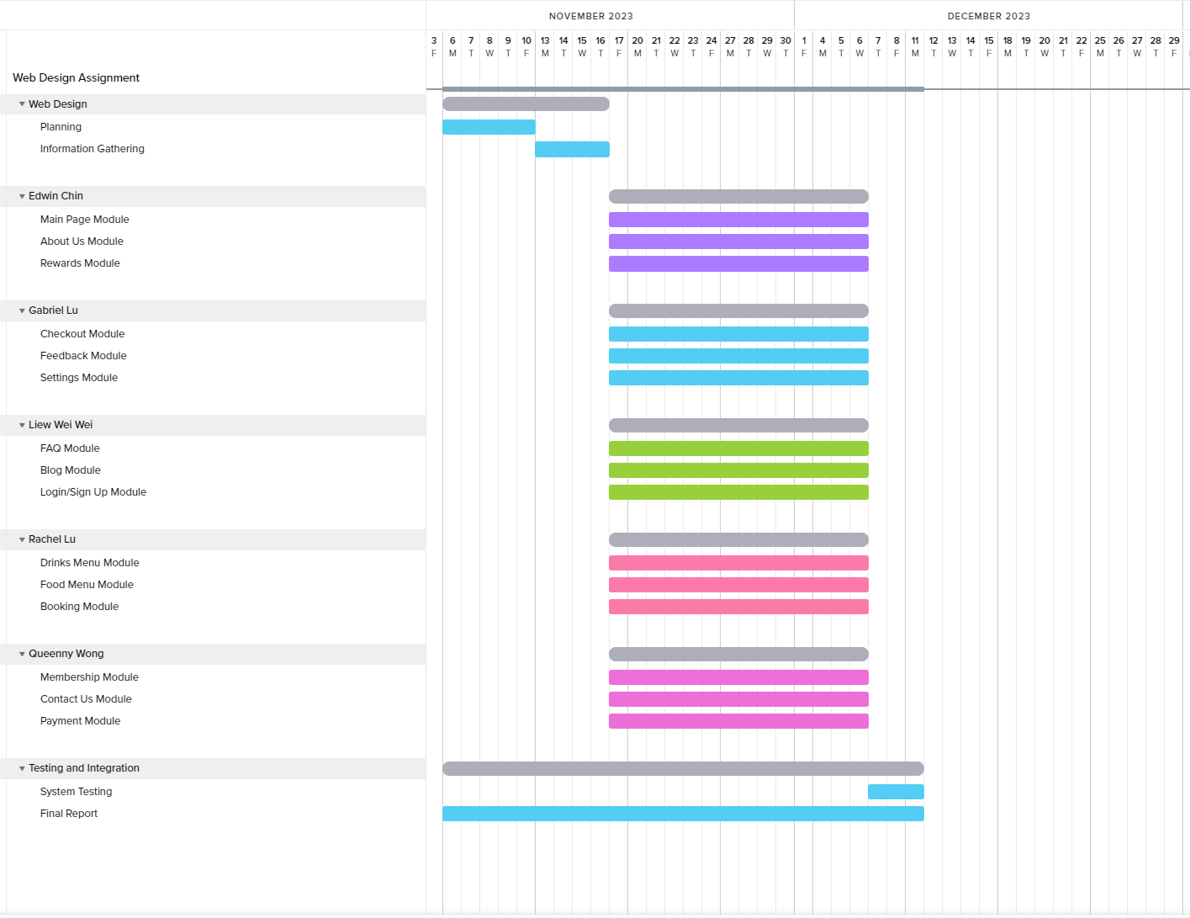

***3.0 Website Module***

3.0.1 Main Page Module

This module is designed to be the landing page for users which displays general information of Kohi for the users of the website. Information provided are facts about the store, preview of products which includes drinks and a booking option.

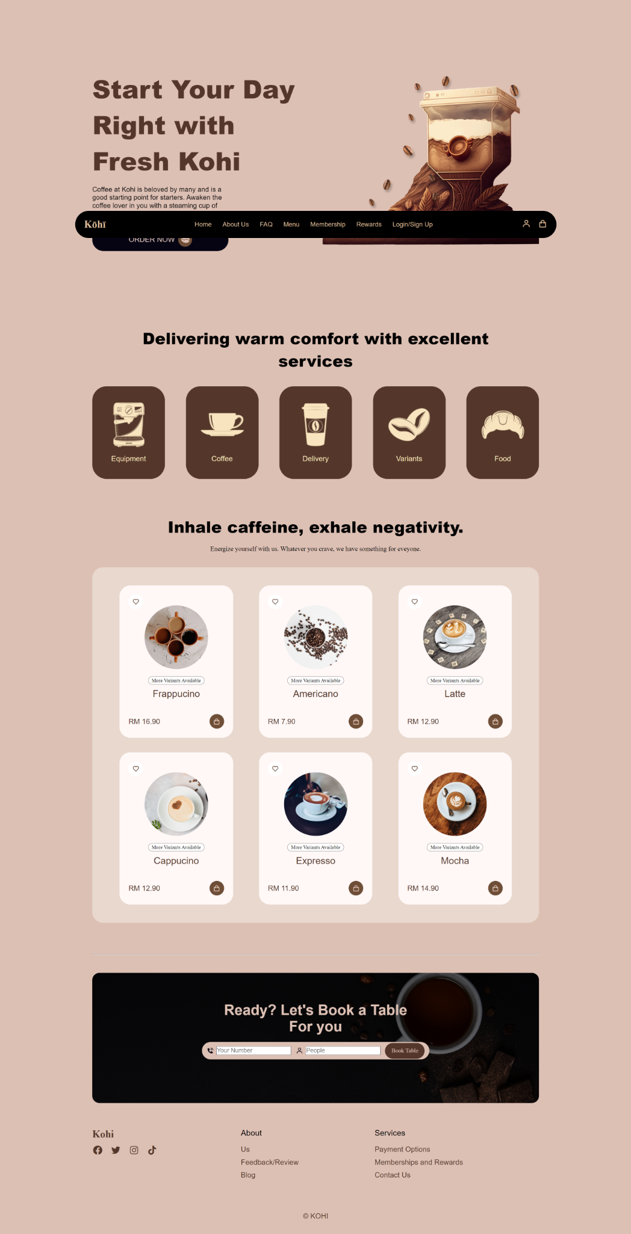

3.0.2 About Us Module

This module is designed to give an in-depth description of the management of Kohi and its business philosophy. It also provides education towards the users who access this site towards the services and products that they pride themselves in.

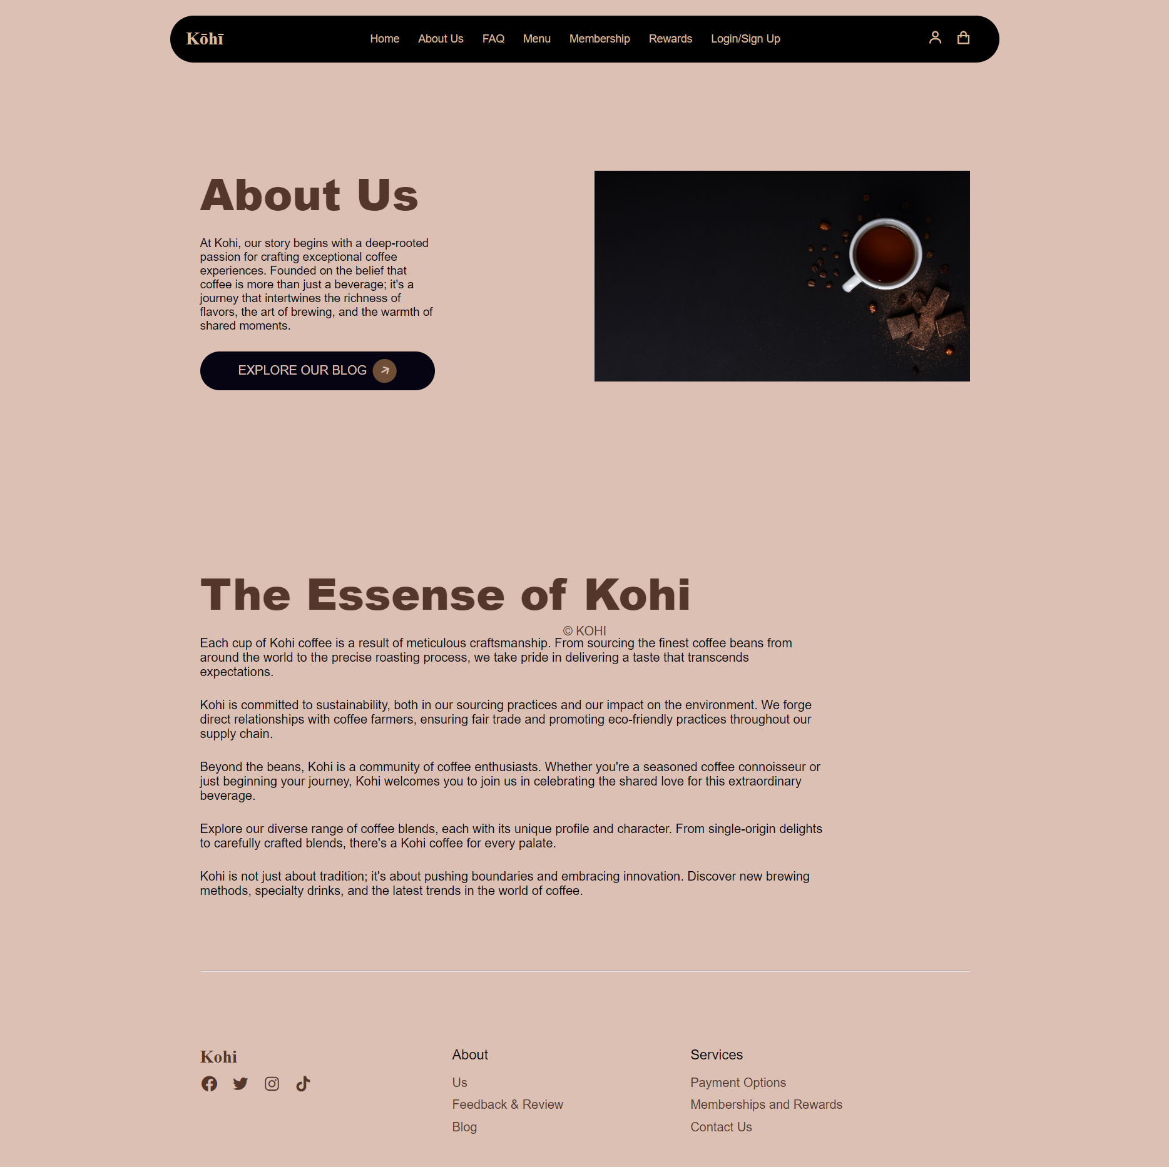

3.0.3 Rewards Module

This module is designed to showcase the perks and benefits of being a member at Kohi. Moreover, registered members can view their membership status on getting a reward which usually includes free or discounted deals.

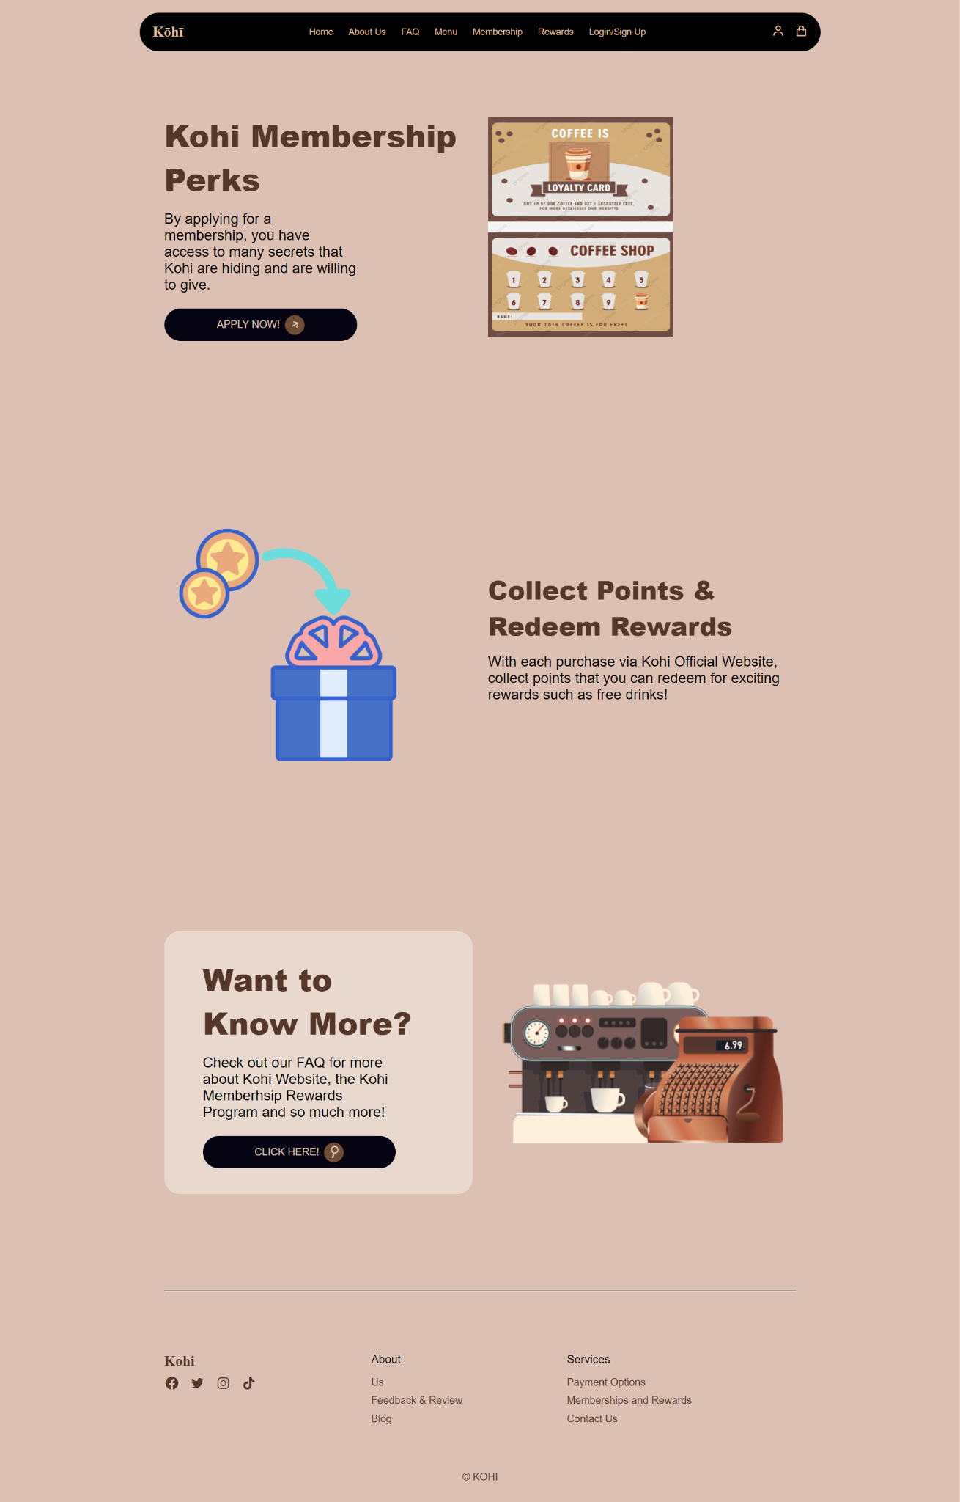

3.0.4 Login/Signup Module

This module allows the users to create an account on the Kohi website to access premium deals and services that only users that are registered are able to use.

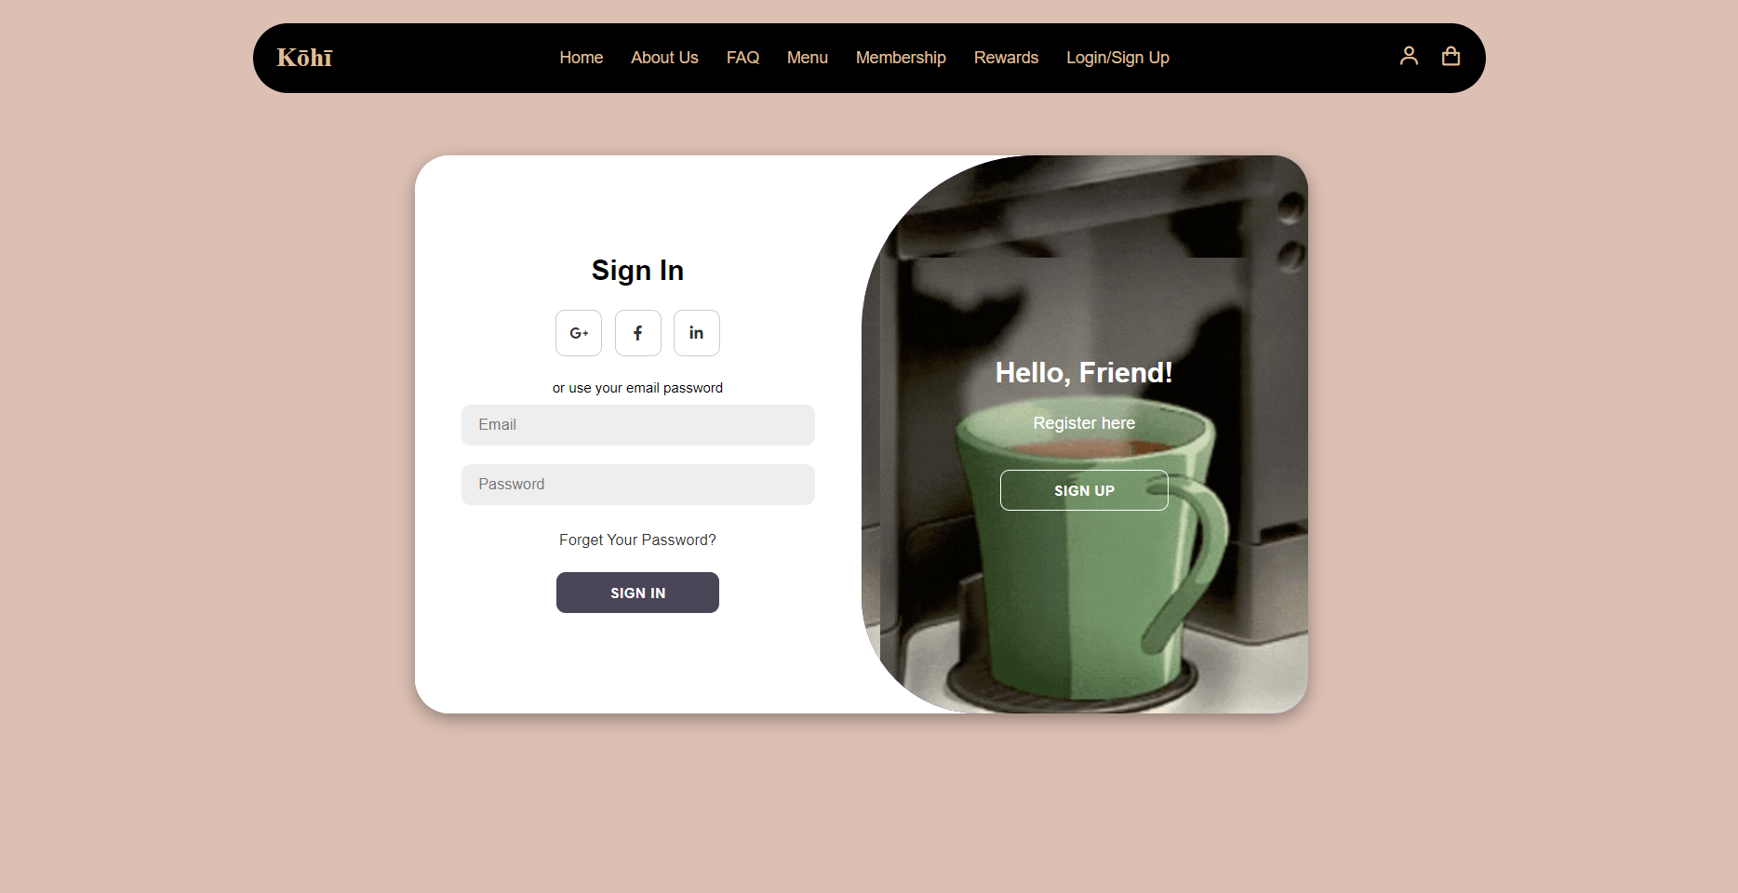

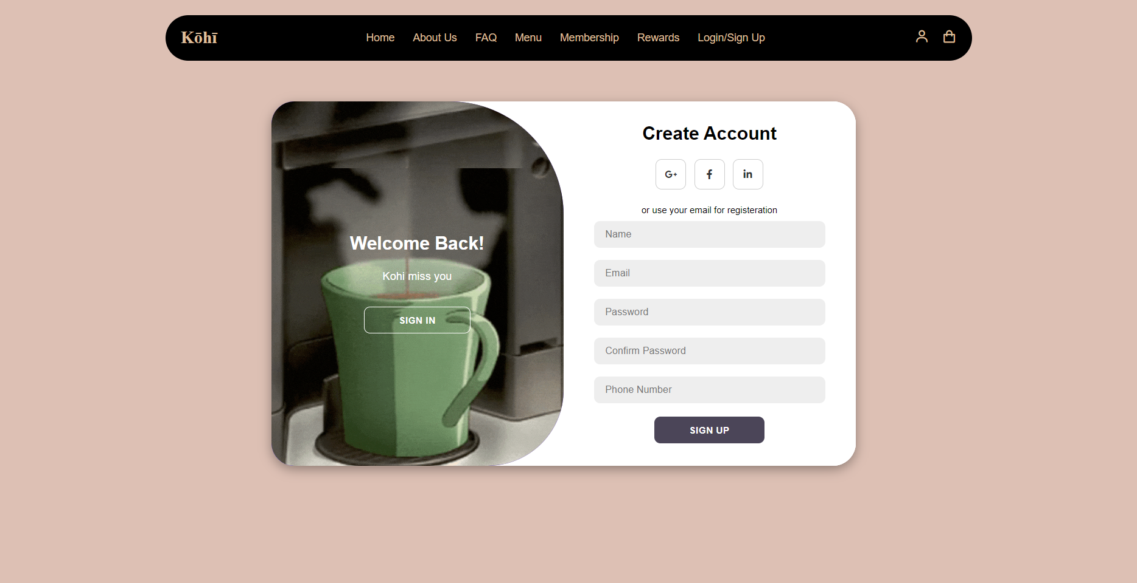

3.0.5 Blog Module

This module is designed to show Kohi’s gallery and photos of their products taken during services throughout its opening. Photos include their current products and previous time-limited products.

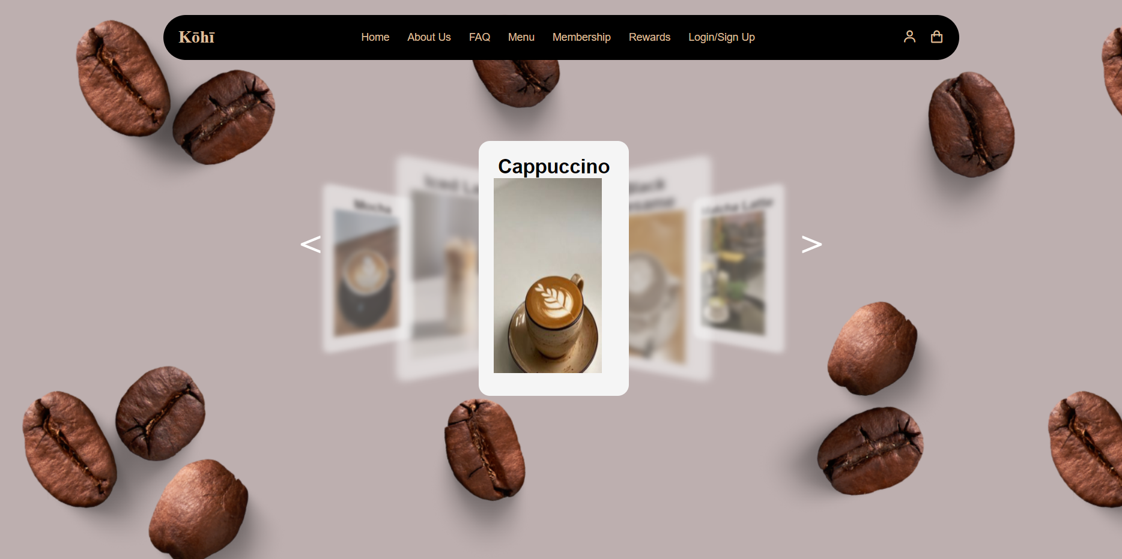3.0.6 FAQs Module

This module is designed to answer general questions about Kohi to let the users have a better understanding of the services and products offered and provided by the coffee store. If the user has lingering questions that are not answered in the FAQ, they may use the Feedback/Review Module to have their personal questions answered directly.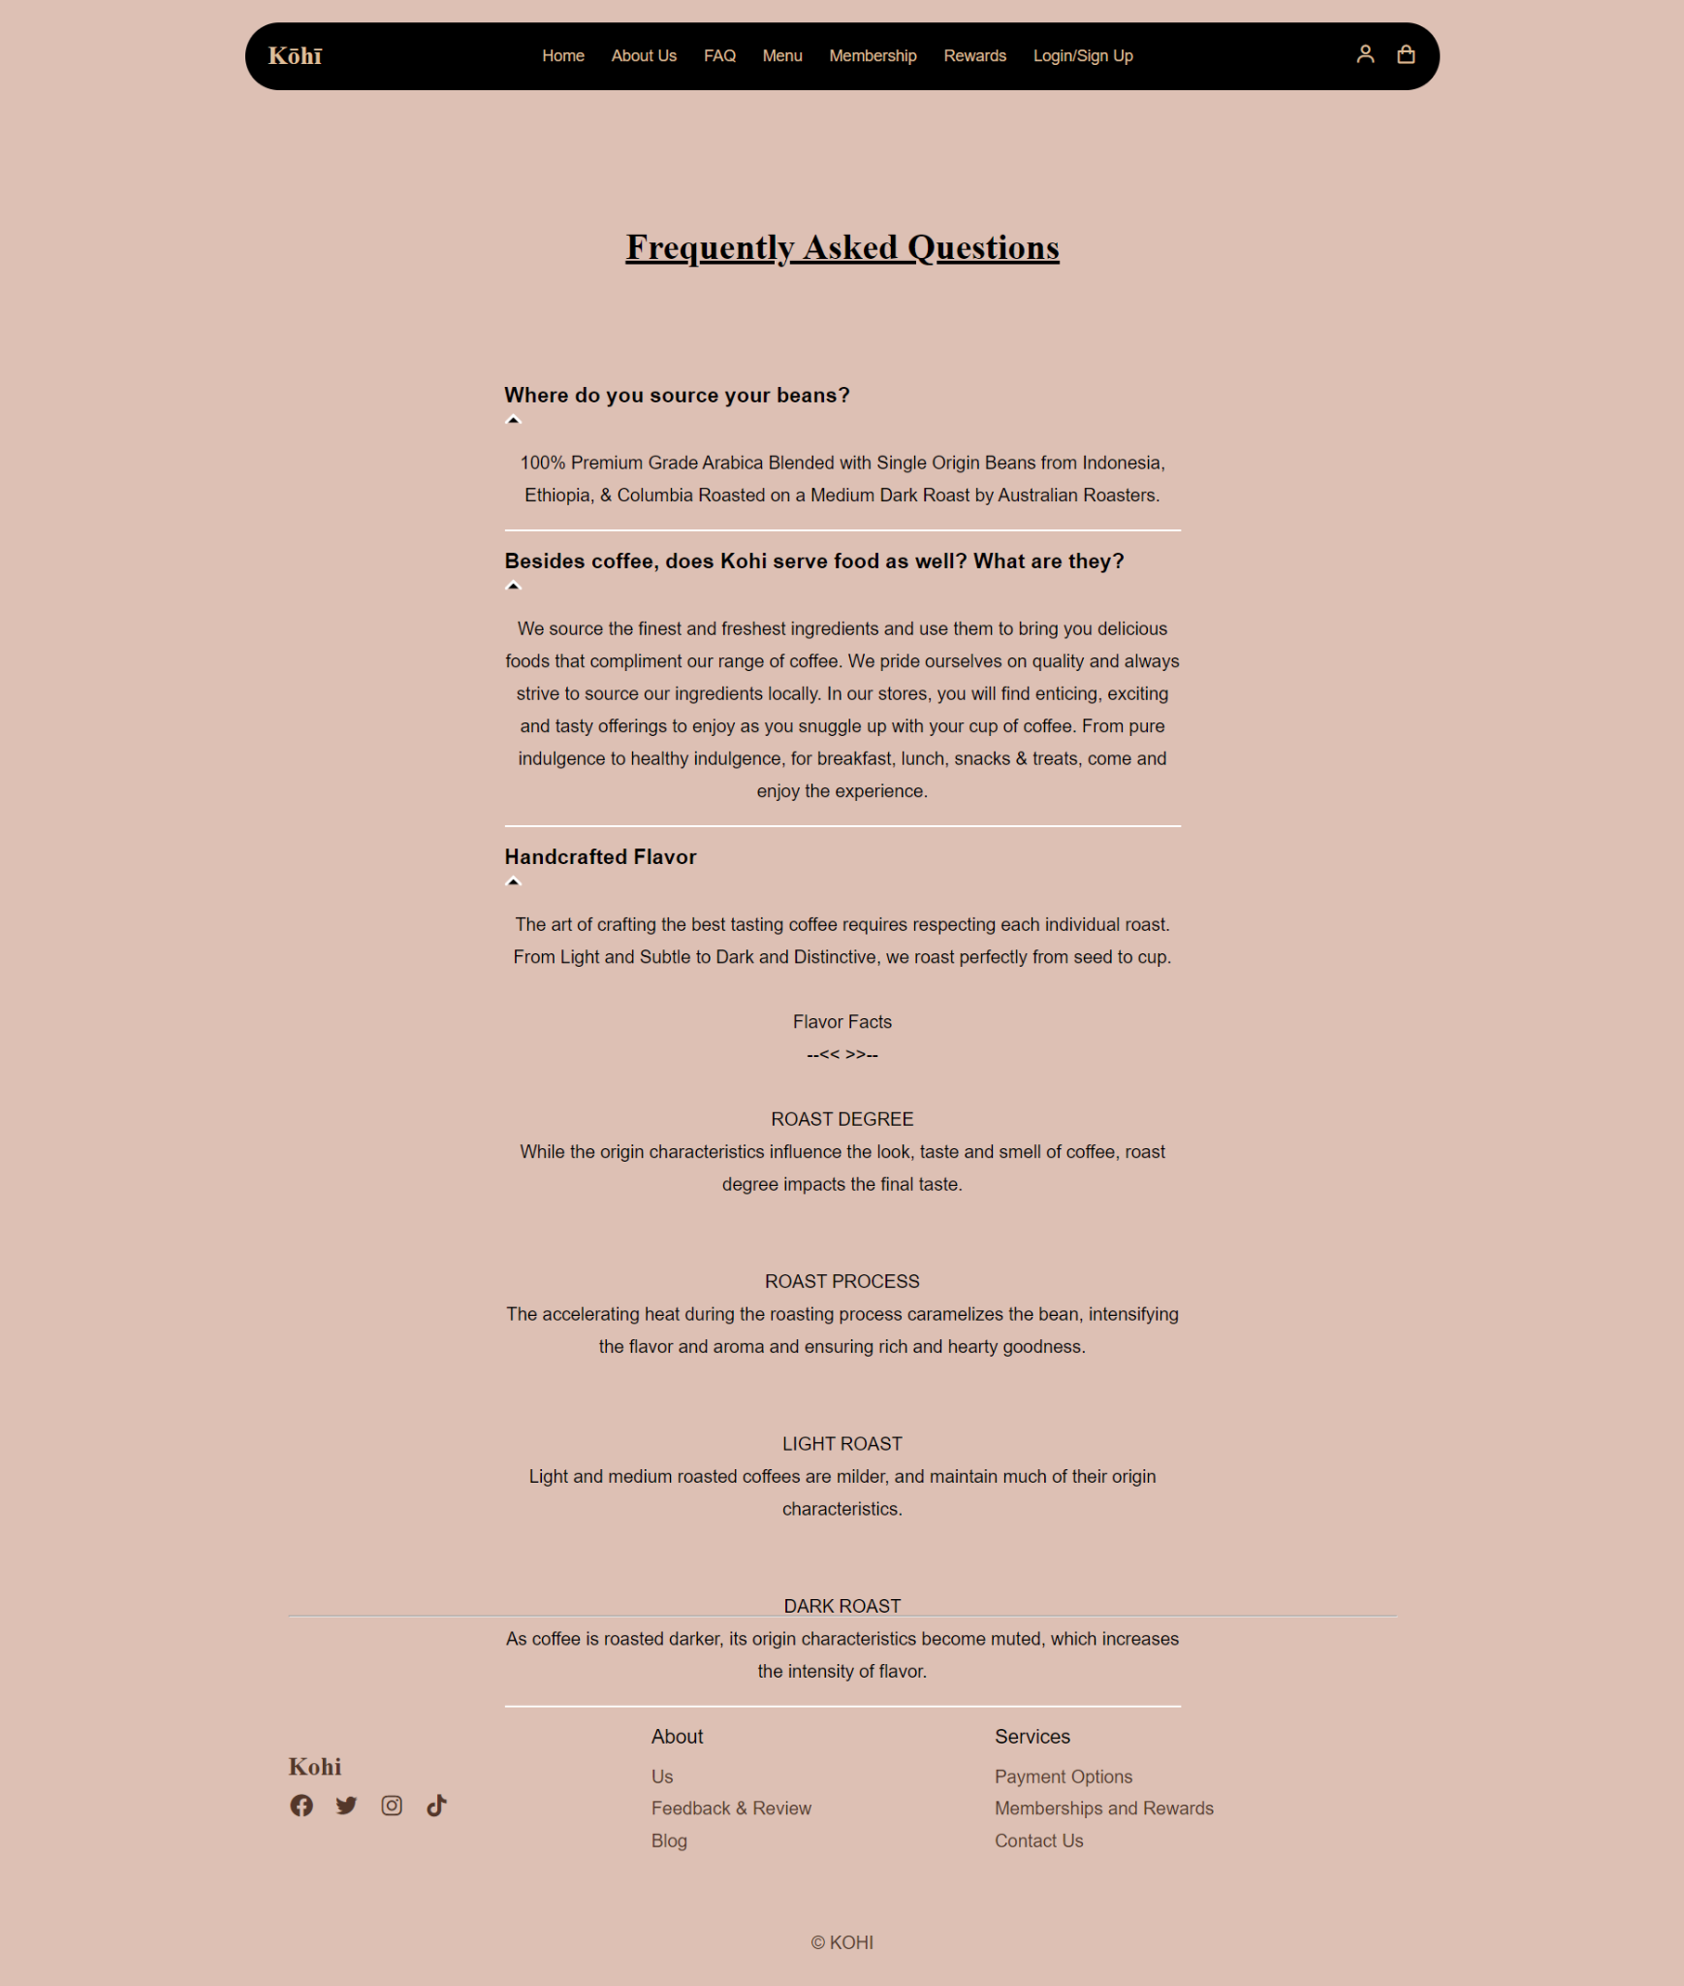

3.0.7 Payment Module

This module is designed to allow users to make payment using the website with the options of using credit and debit cards or localized online payment applications such as Touch’nGo eWallet, Boost and MAE Wallet.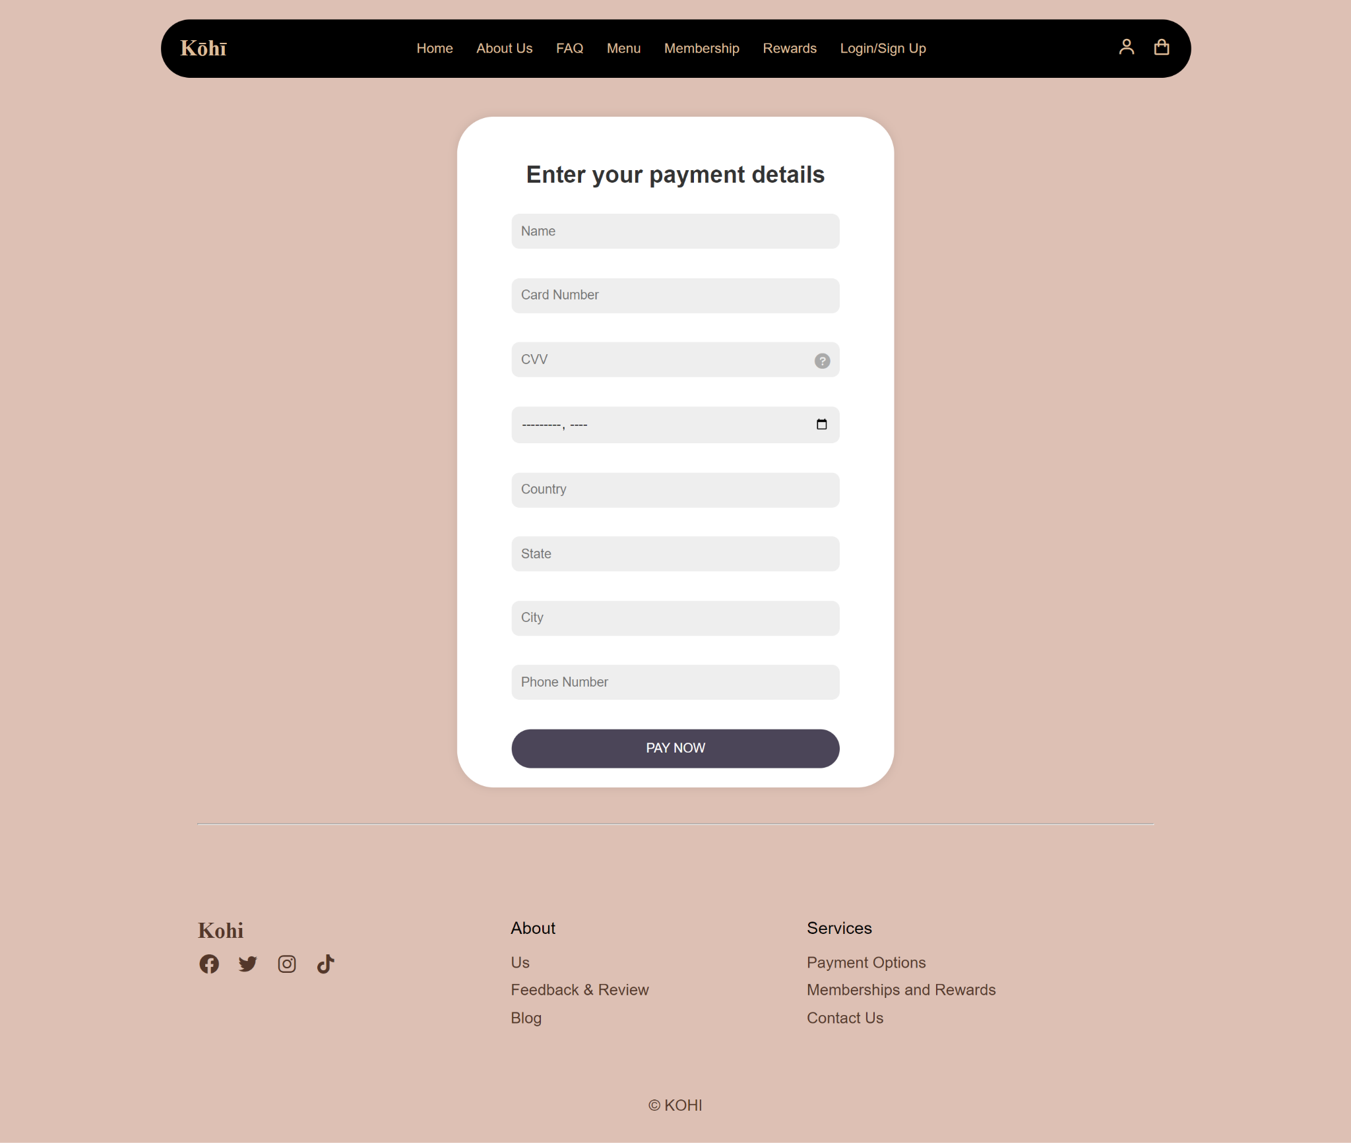

3.0.8 Membership Module

This module allows the user to apply for a membership at Kohi to join the Kohi Member Club via an online submission form after the user has registered an account.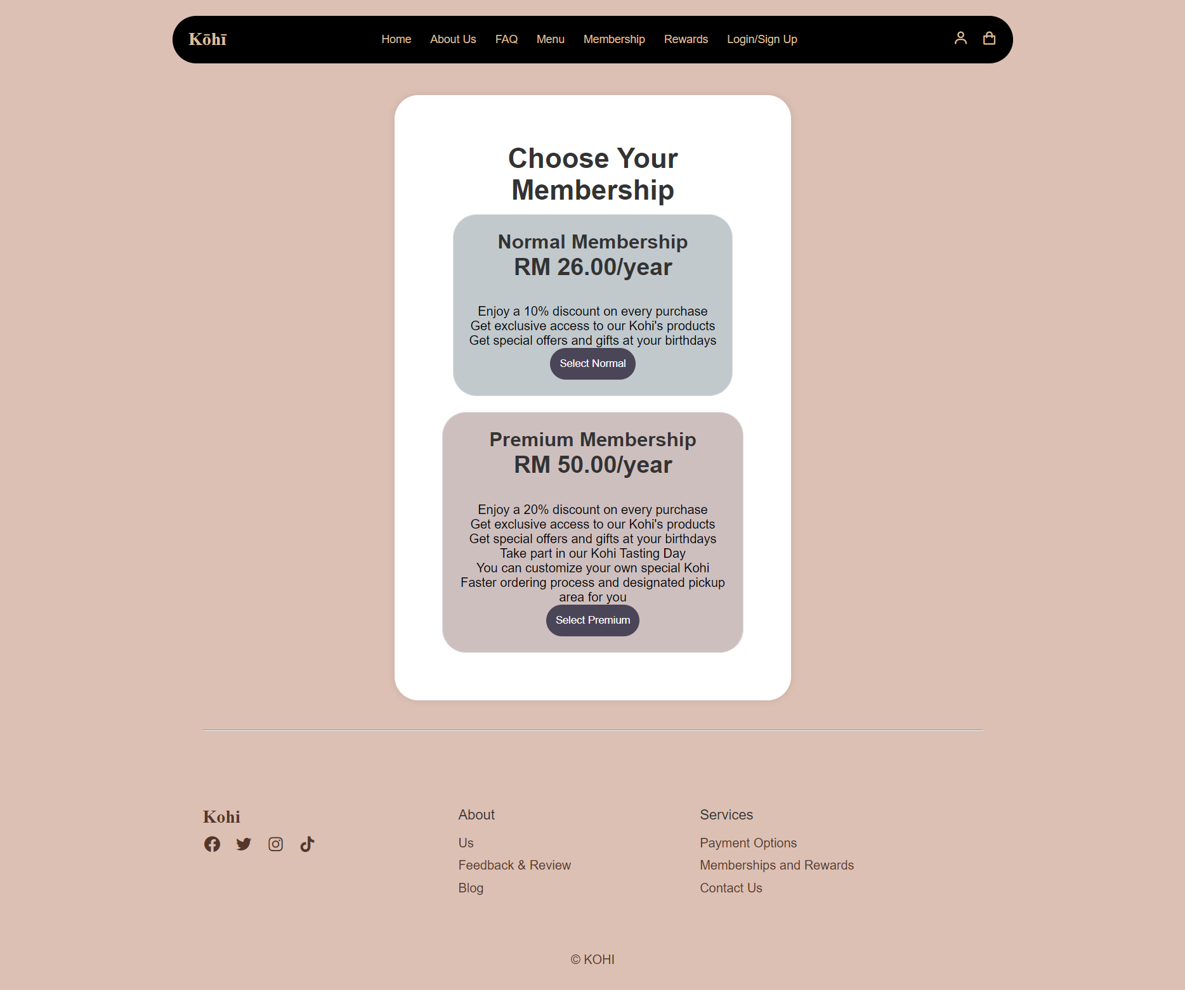

3.0.9 Contact Us Module

This module contains the company’s email address, phone number and social media links for the user to contact and access. Apart from that, a table containing the opening and closing hours of the store is present in the module.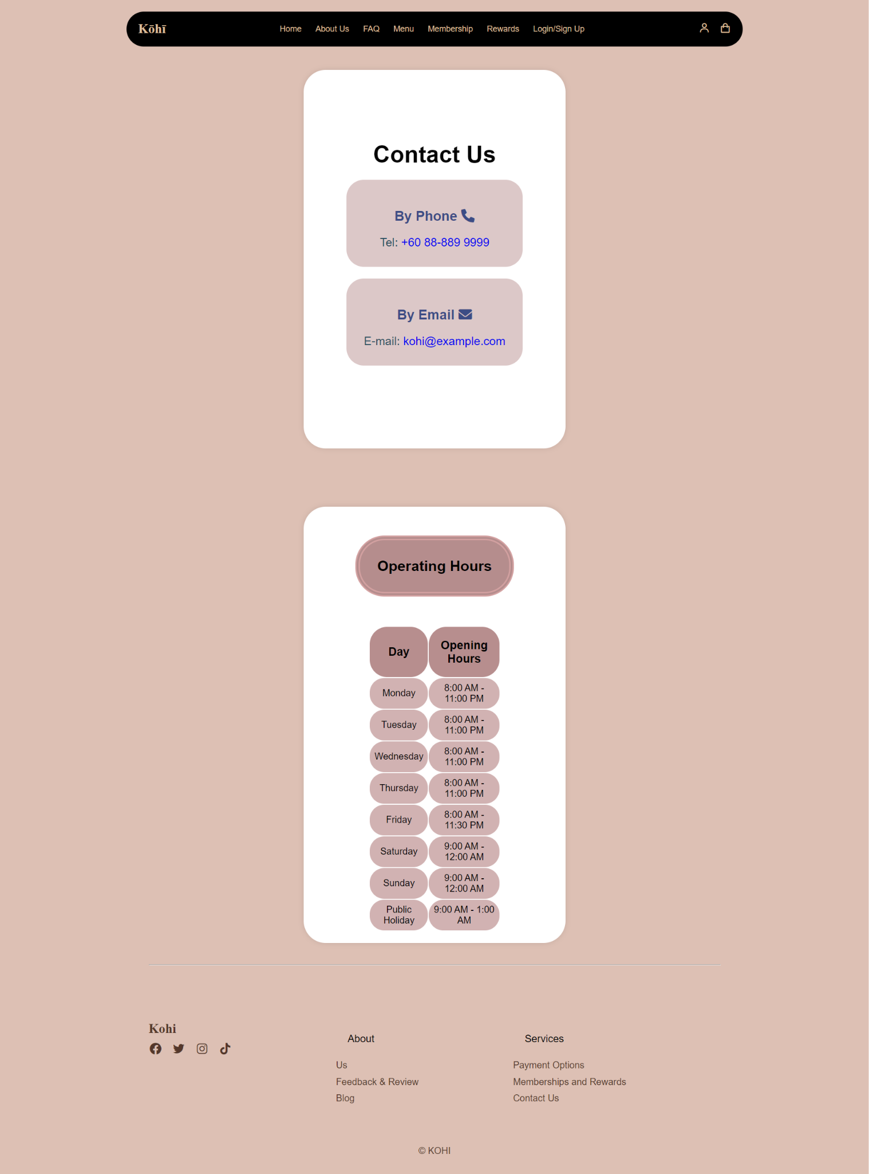

3.0.10 Drink Menu Module

This module is designed to house the drinks options of Kohi. The contents showcases the drinks that Kohi has to offer which includes limited time offers too, the menu option on the side navigation bar is defaultly set in the food menu for easy access.

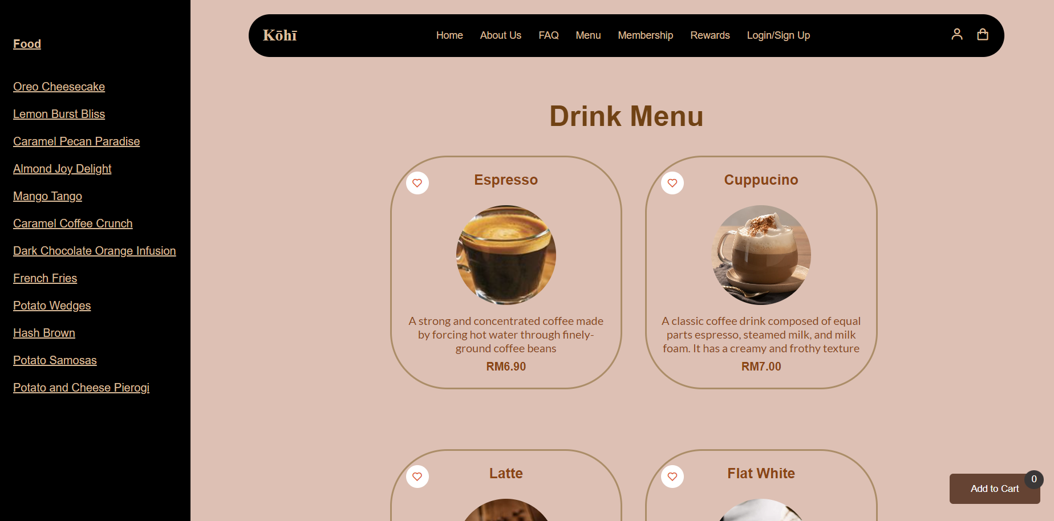

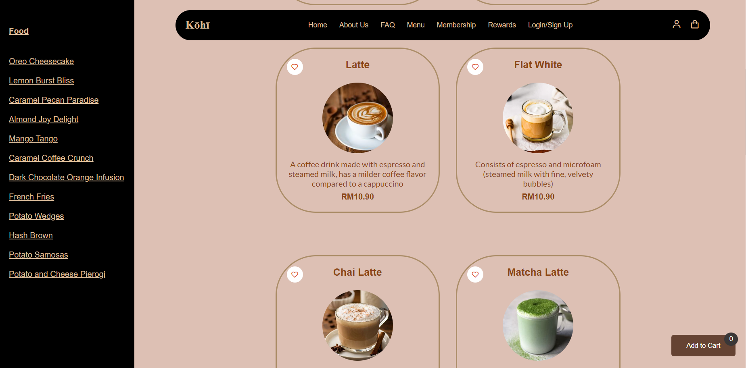

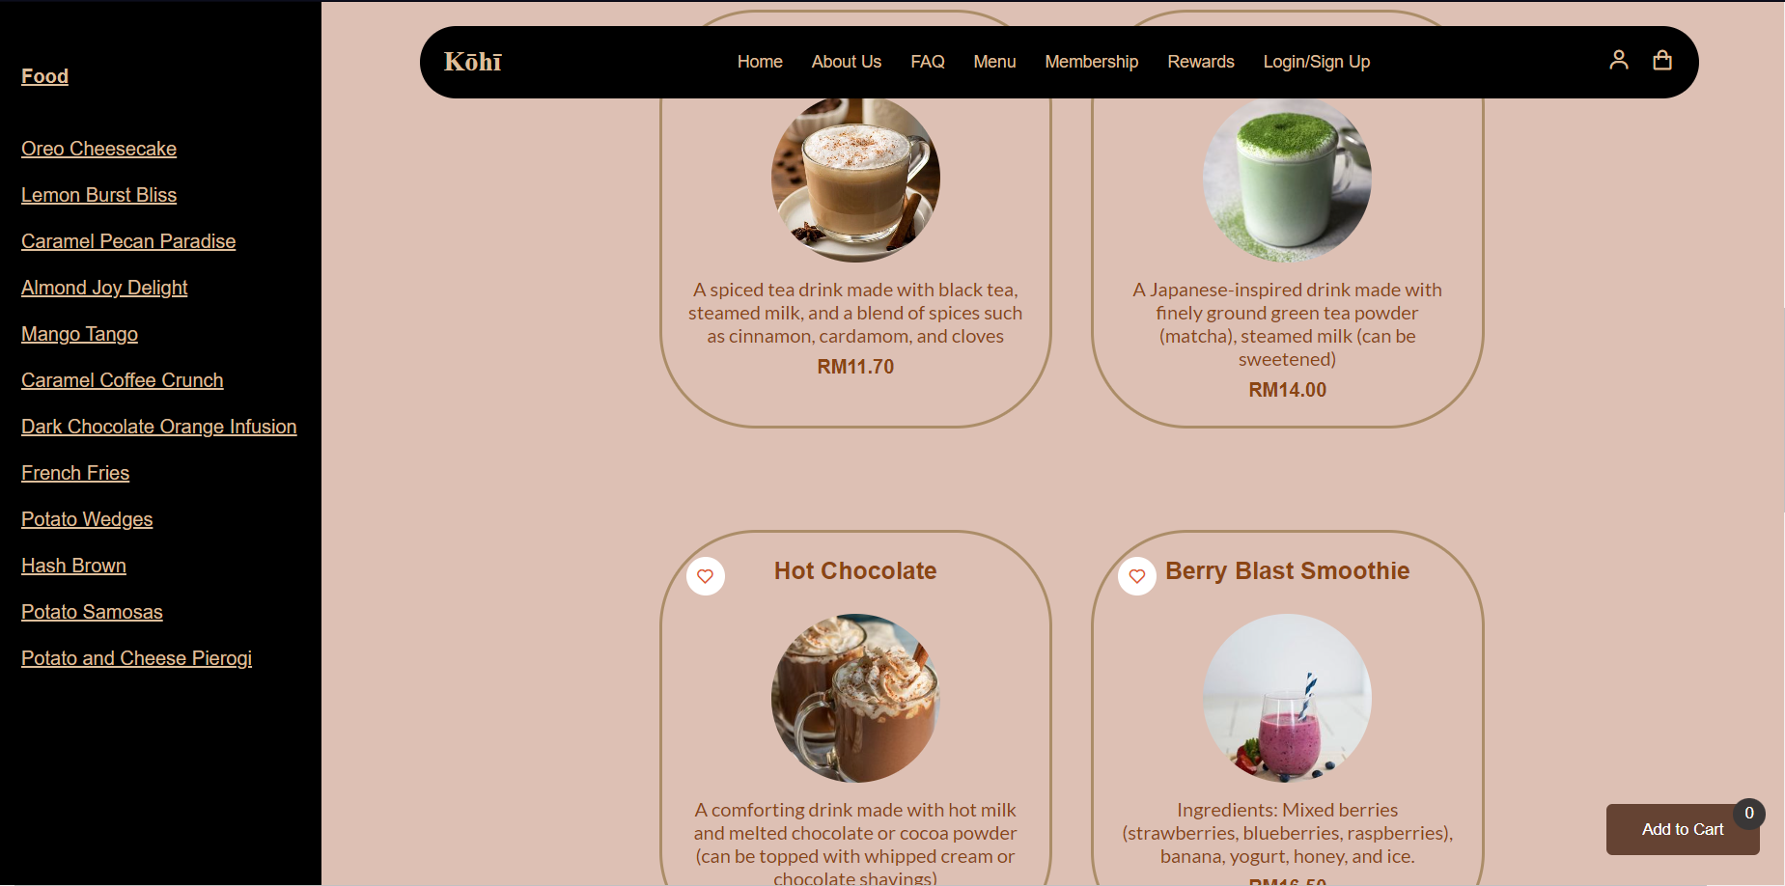

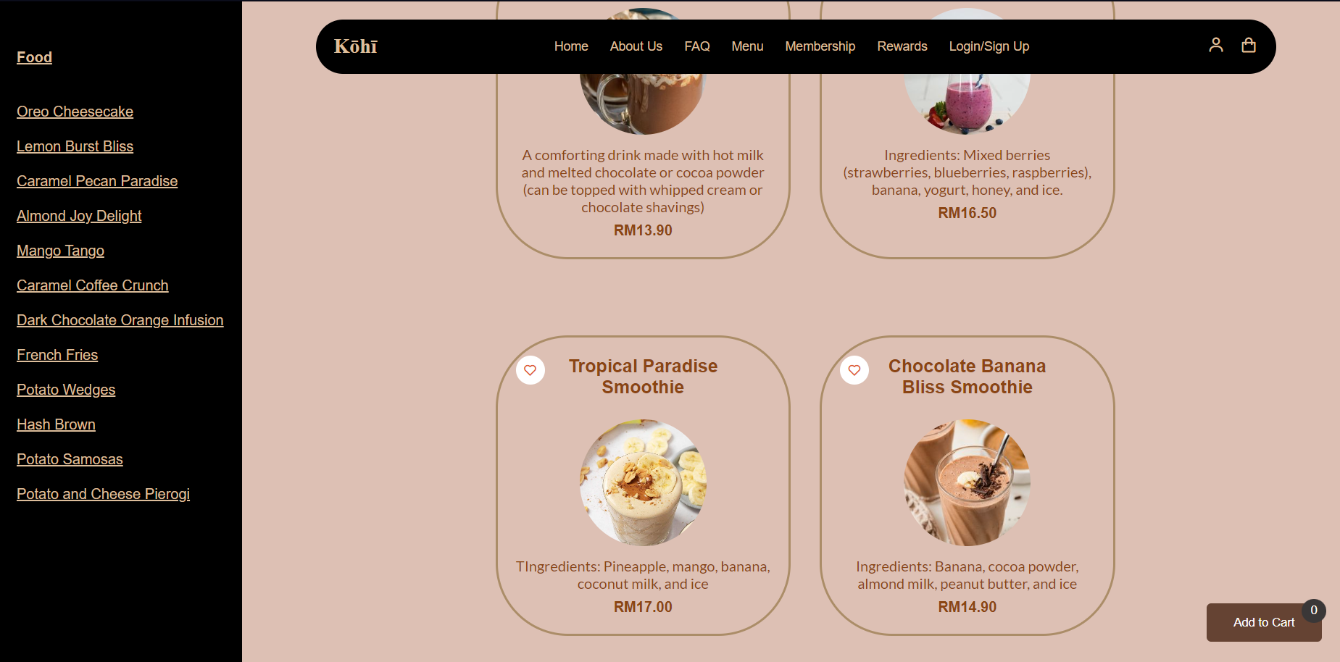

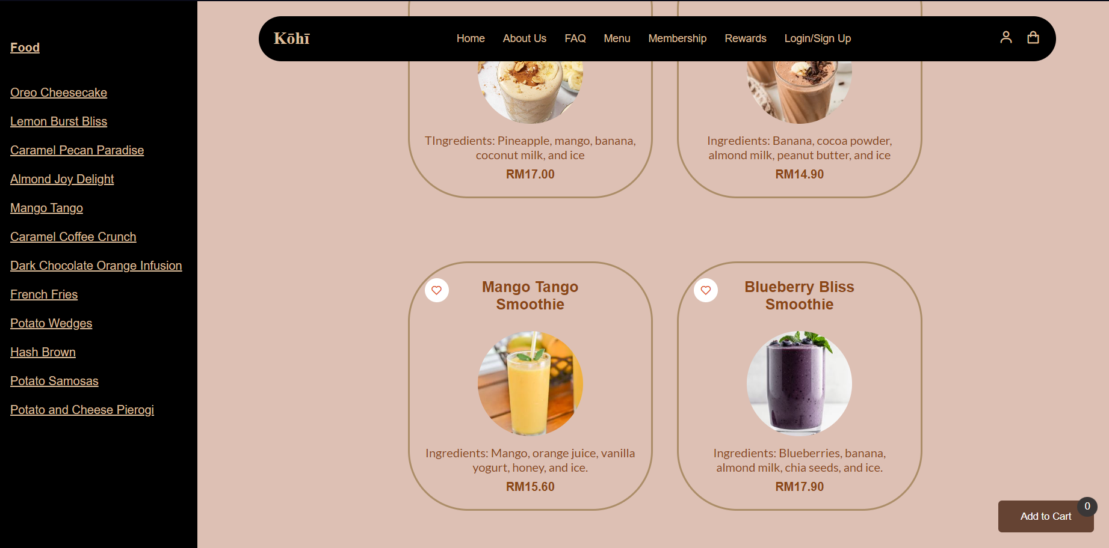

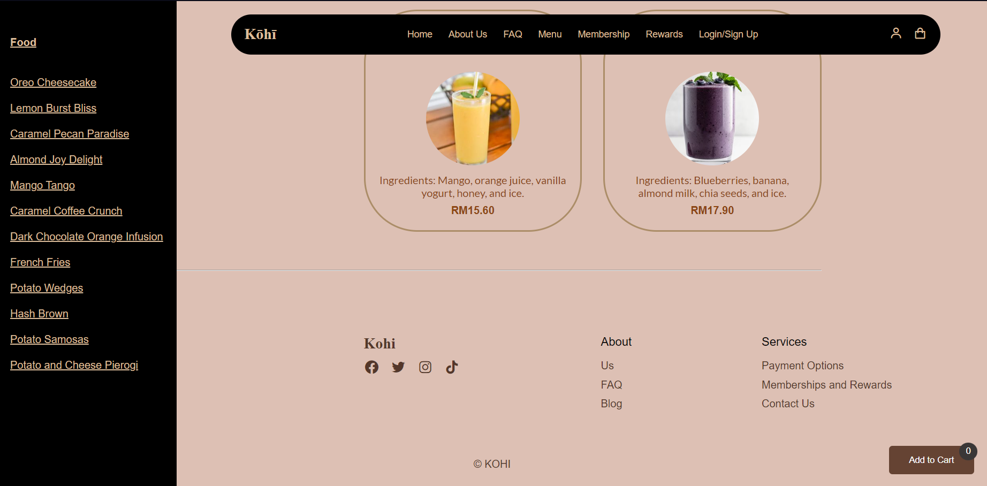

3.0.11 Food Menu Module

This module is designed to house the food options of Kohi. The contents showcases the food that Kohi has to offer which includes limited time offers too, the menu option on the side navigation bar is defaultly set in the drinks menu for easy access.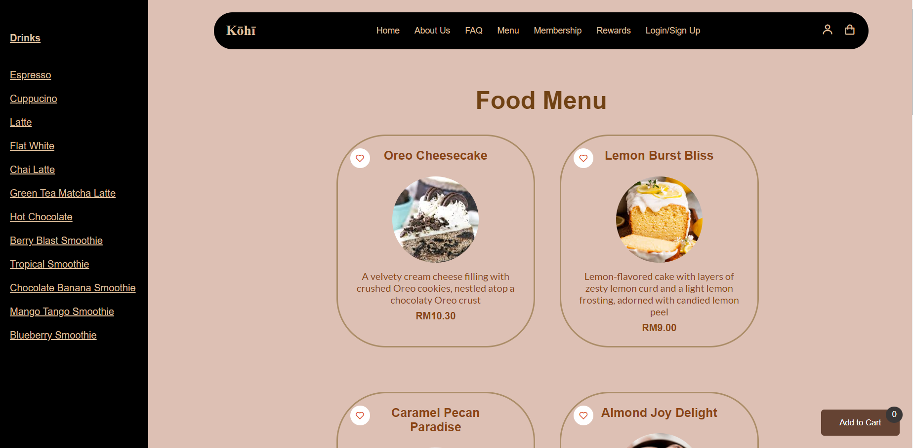

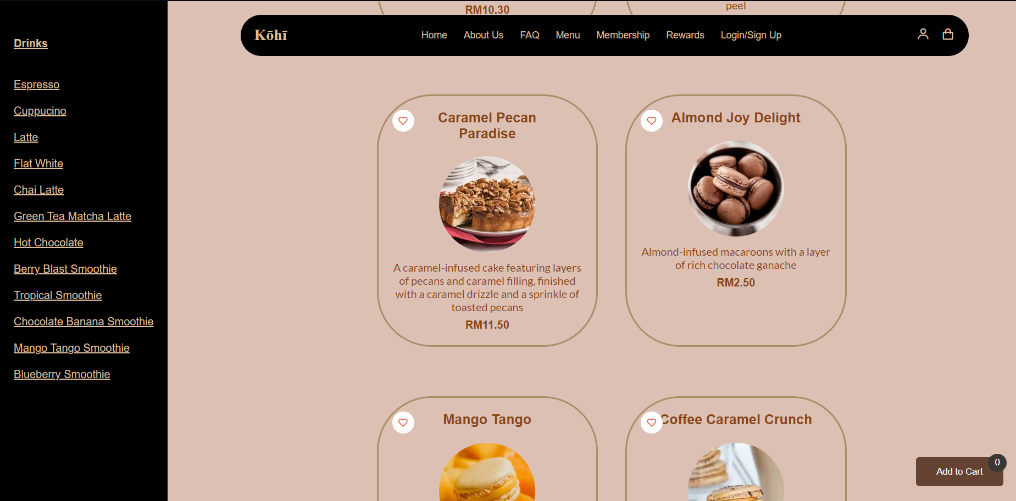

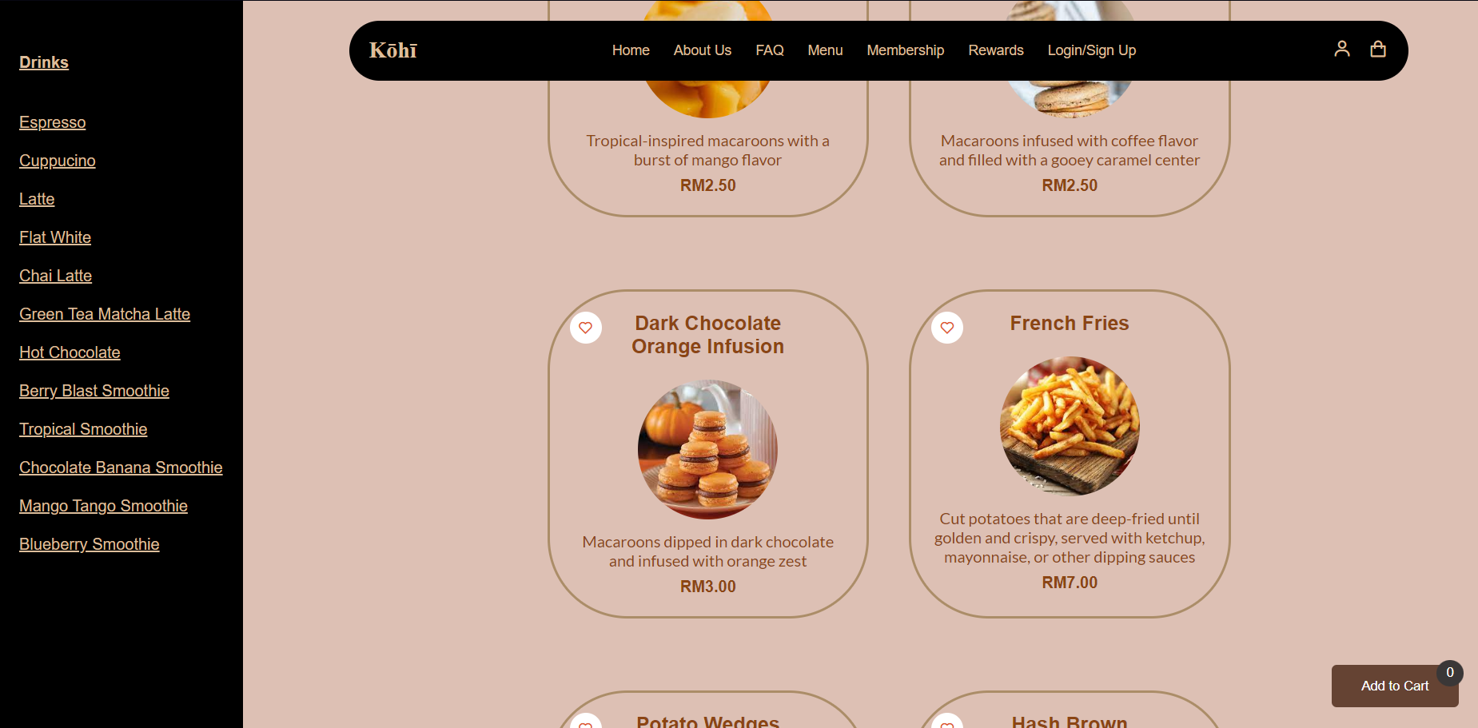

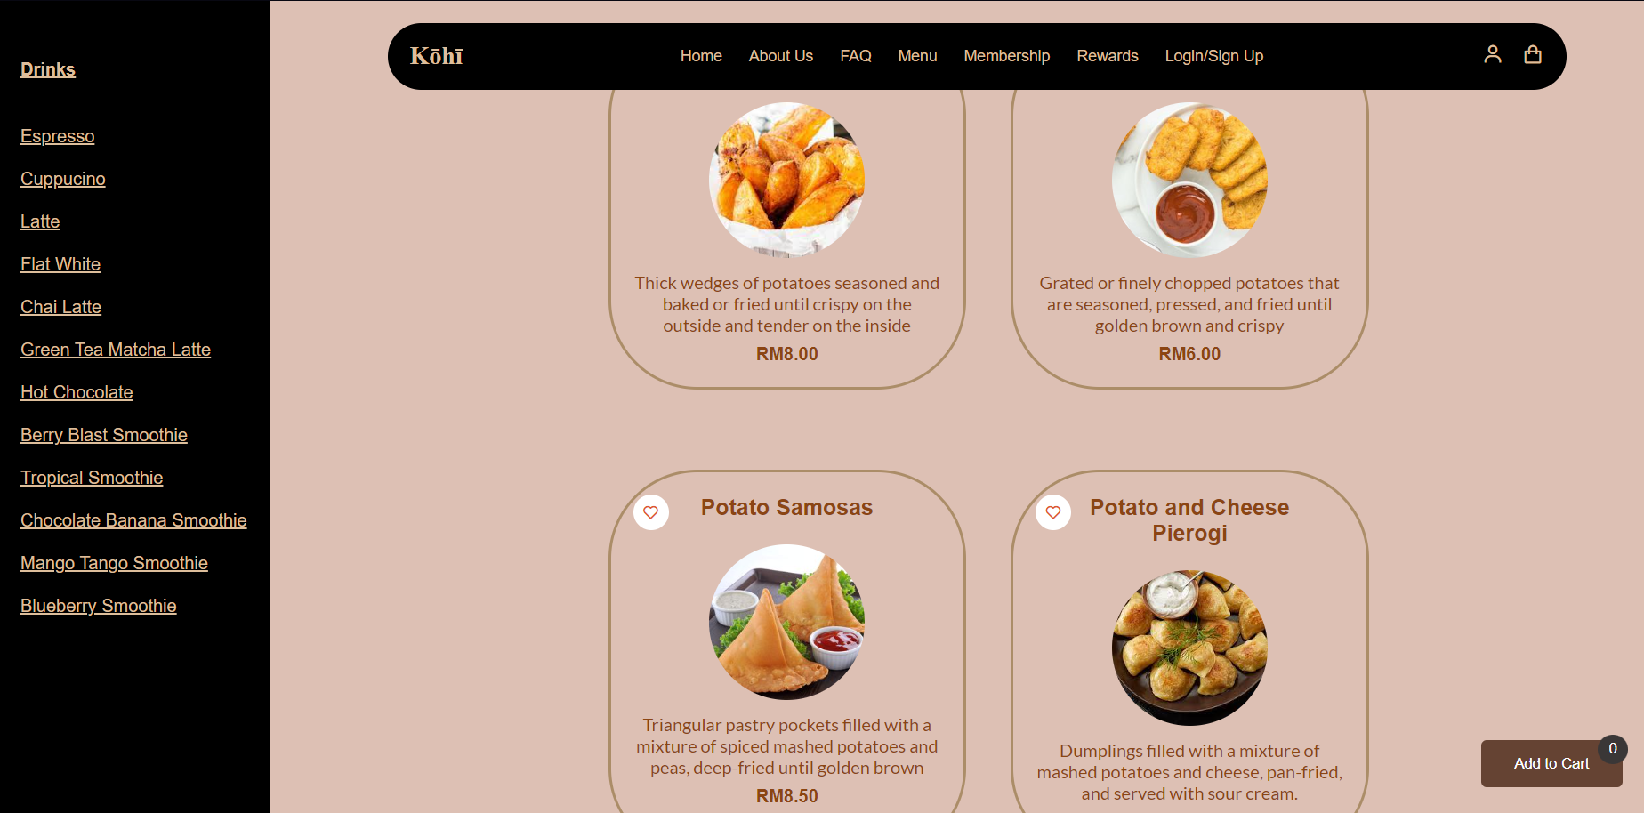

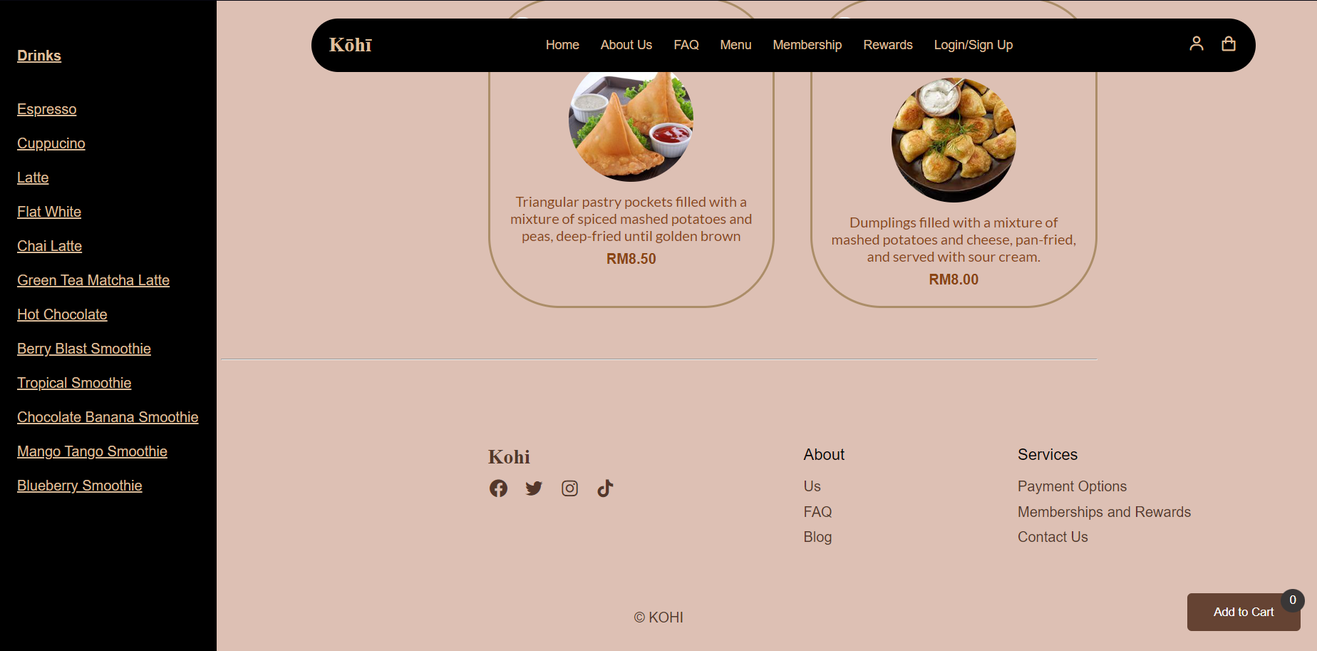

3.0.12 Booking Module

This module is designed to allow users to make bookings and reservations for tables in Kohi. After inputting the required information, the system will use the website to inform the user the successability of the reservations.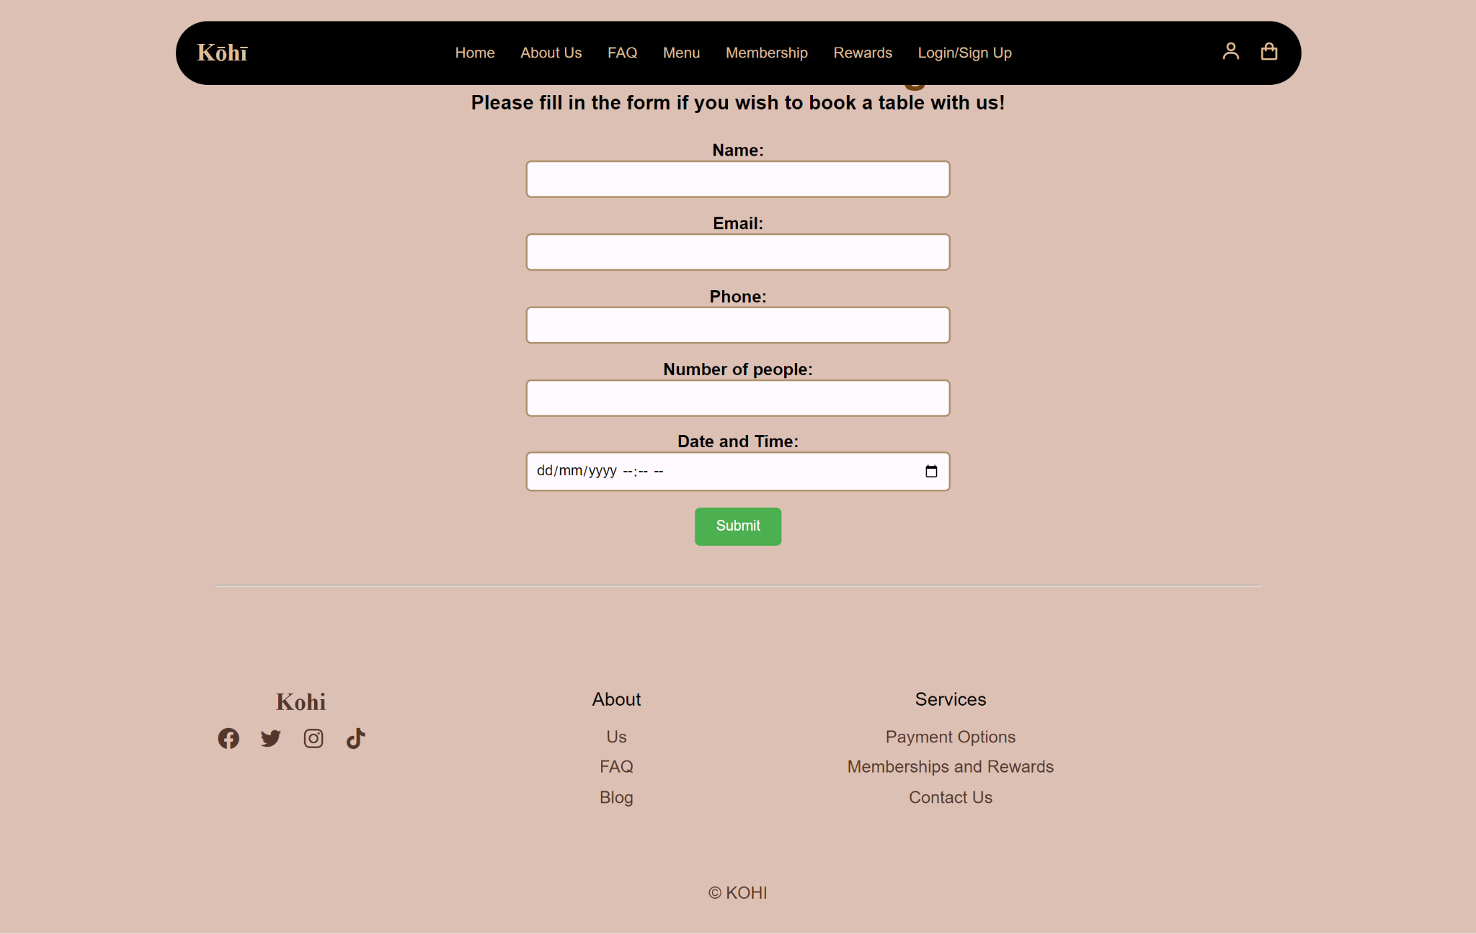

3.0.13 Settings Module

This module is designed to let the registered users edit their accounts according to their preferences with language editing and theme editing. Moreover, it allows the users to add payment methods of their desired preferences.

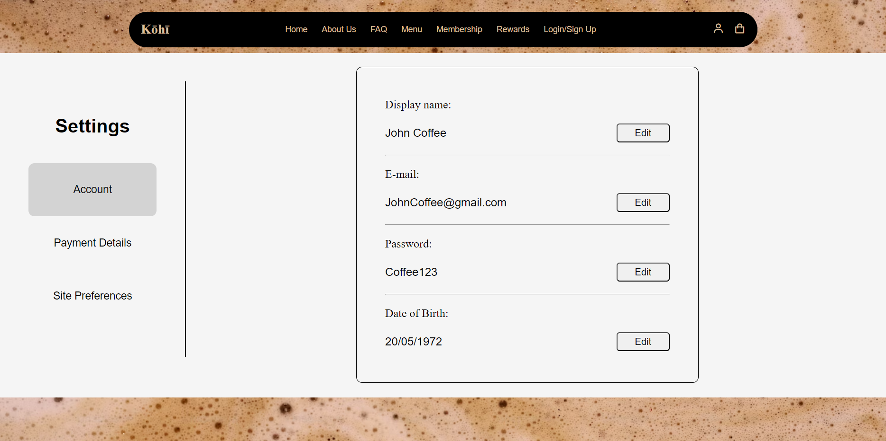

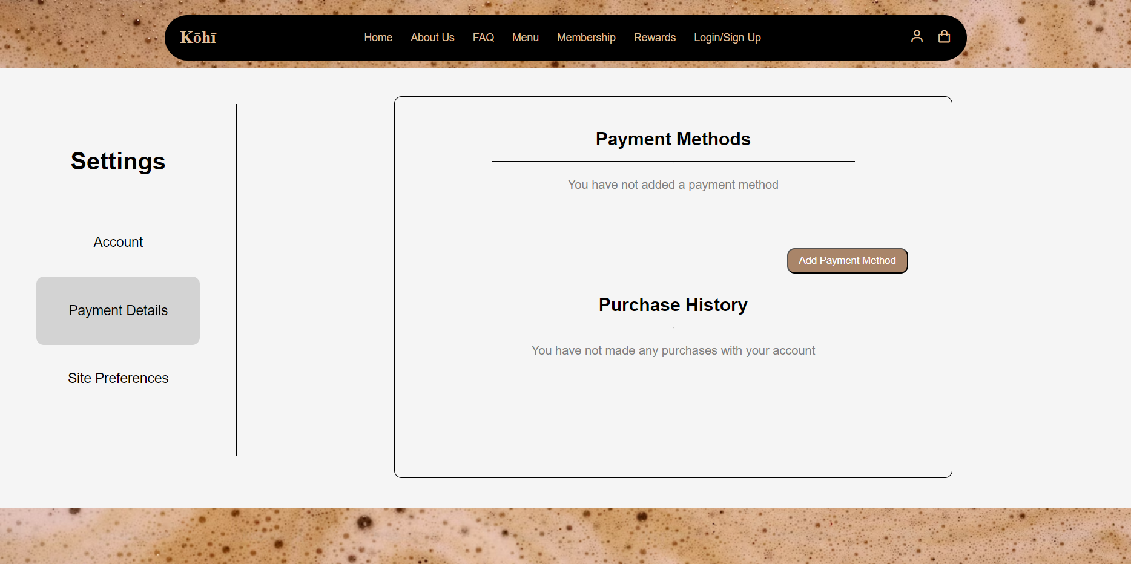



3.0.14 Checkout Module

This module is designed to allow users to add products of their choice into a specialized cart feature that will auto calculate the pricings of all products to inform the user of the final price.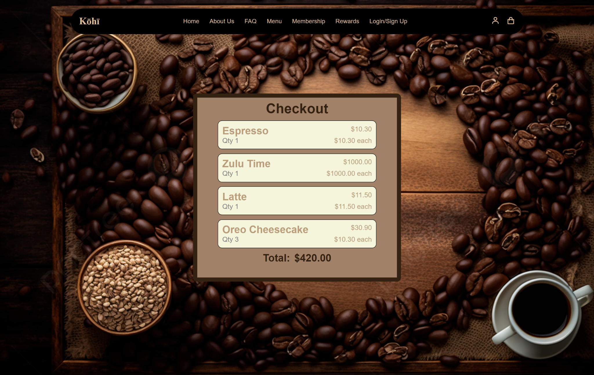

3.0.15 Feedback Module

This module is designed to let the user input their thoughts and reviews of the services and products of Kohi, which includes positive and negative feedback. Other than that, this module also allows users to ask questions that are not answered in the FAQ.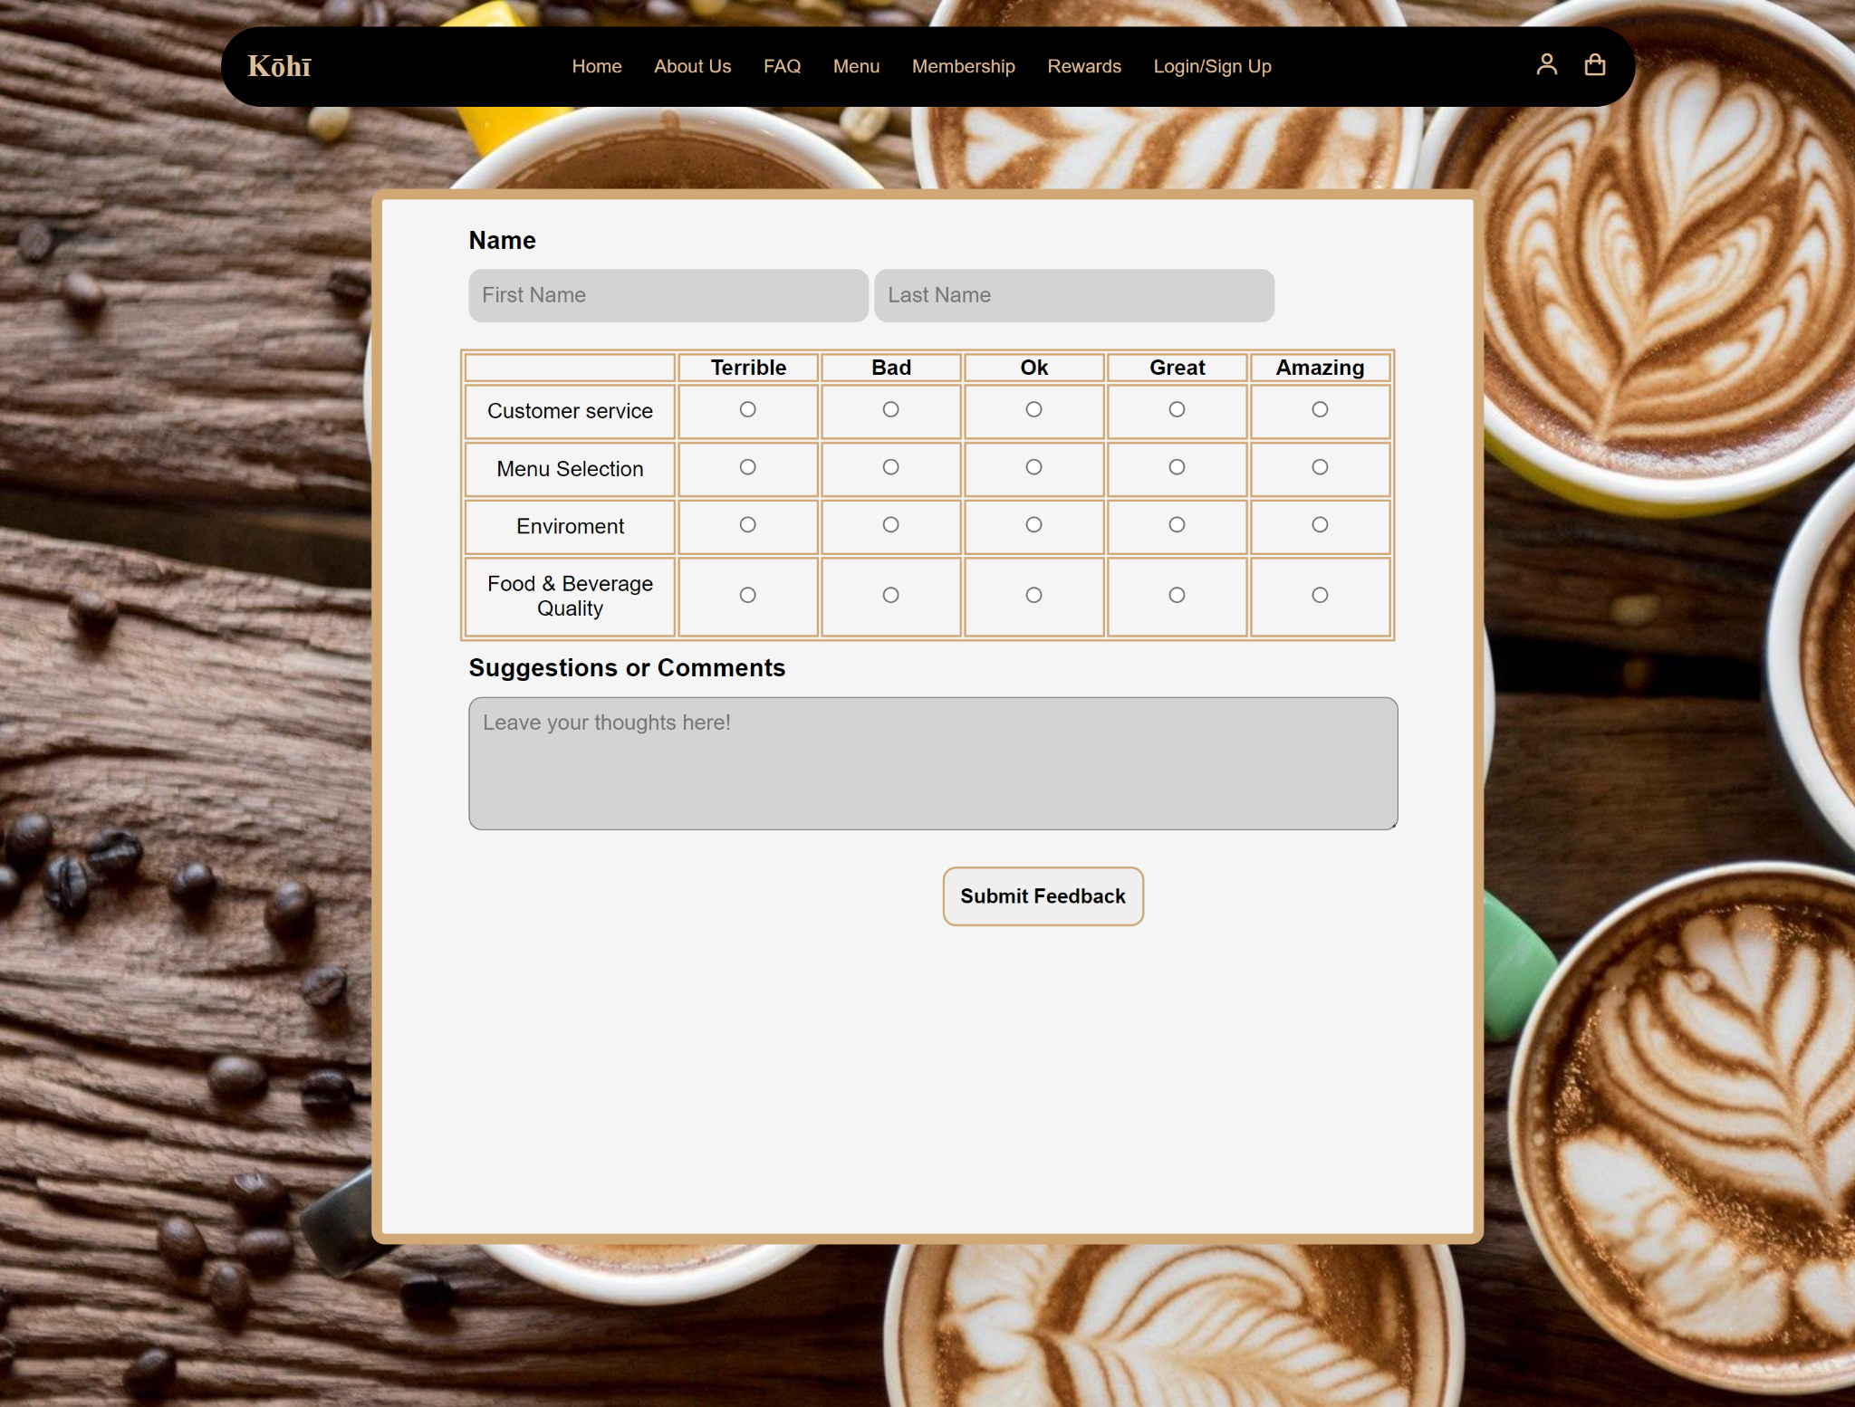

**References**

**Media file used in mp_home.html**

CarpoolVenom Youtube. Available at

<https://www.youtube.com/watch?v=ENwdYIwkEpc> (Accessed: 26 November 2023)

**Media file used in Blog page**

Anna Blok-Frontend Tutorials

<https://youtu.be/1CZhGDU5cWM?si=NFdhHdjaiX6BD1f> (Accessed: 19 December 2023)

CodingNepal

<https://youtu.be/7HPsdVQhpRw?si=1OQeIgTo92Uyw8yf> (Accessed: 19 December 2023)

ProgrammerCloud

<https://youtube.com/shorts/4tzMi6G7a7w?si=DkJhTbG2V6TYN-Fk> (Accessed: 20 December 2023)

SairProgramming

<https://youtube.com/shorts/0dXyetSW-Ro?si=QtKt7VhEq1FJ36Qi> (Accessed: 20 December 2023)

Pictures taking from myself (Accessed: 13 December 2023)

**Media file used in Account and login page**

Hash Techie

<https://youtu.be/RbXN8j37Fe4?si=nC3W-pN6tih18MMG> (Accessed: 14 December 2023)

Seek coding

<https://youtu.be/GMLsHHHOnjw?si=9G8ih75LuPZpPuGS> (Accessed: 1 December 2023)

Book- HTML & CSS (design and build website) JON DUCKETT (Accessed: 1 December 2023)

**Media file used in FAQs**

Mr.Web Designer

<https://youtu.be/3i7vsWGlU90?si=jS-V7KL4dsiKr0-H> (Accessed: 18 December 2023)

Gradestack

<https://youtu.be/oCx4gtYe410?si=OrRxpz-cTd87mSJs> (Accessed: 18 December 2023)

**Media file used in set background image**

<https://youtu.be/HEpqi6im8CY?si=Z06oByneqOL0CkSX> (Accessed: 1 December 2023)

Media file used as background image in Settings

<https://unsplash.com/photos/a-close-up-of-a-brown-substance-in-a-bowl-YvyobtVNQJs> (Accessed: 24 December 2023

Media file used as background image in Feedback

<https://wallpapercave.com/w/wp6511626> (Accessed: 24 December 2023)

Media file used as background image in Payment Checkout

<https://pngtree.com/freebackground/coffee-beans-desktop-coffee-mug_2393774.html> (Accessed: 24 December 2023)

**Media file used in payment page**

Learning Axis

<https://www.youtube.com/watch?v=yKqeELD1kxs&pp=ygUTcGF5bWVudCBodG1sIGNzcyBqcw%3D%3D> (Accessed: 22 December 2023)

**Media used in food menu**

<https://www.lifeloveandsugar.com/best-oreo-cheesecake/> (Accessed: 22 December 2023)

<https://www.recipetineats.com/glazed-lemon-loaf-quick-bread/> (Accessed: 22 December 2023)

<https://www.imperialsugar.com/recipes/sticky-caramel-pecan-coffee-cake> (Accessed: 22 December 2023)

<https://sugargeekshow.com/recipe/chocolate-macaron-recipe/> (Accessed: 22 December 2023)

<https://www.amorino.com/en/product/mango-macaron> (Accessed: 22 December 2023)

<https://tatyanaseverydayfood.com/caramel-coffee-macarons/> (Accessed: 22 December 2023)

<https://teatimemagazine.com/orange-macarons-with-dark-chocolate-buttercream/> (Accessed: 22 December 2023)

<https://recipes.timesofindia.com/recipes/french-fries/rs54659021.cms> (Accessed: 22 December 2023)

<https://www.errenskitchen.com/seasoned-baked-potato-wedges/> (Accessed: 22 December 2023)

<https://thebigmansworld.com/how-to-make-hash-browns/> (Accessed: 22 December 2023)

<https://recipes.timesofindia.com/recipes/samosa/rs61050397.cms> (Accessed: 22 December 2023)

<https://www.landolakes.com/recipe/9071/potato-cheese-pierogi/> (Accessed: 22 December 2023)

**Media used in drinks menu**

https://www.cocinafacil.com.mx/recetas/cafe-espresso

<https://dairyfarmersofcanada.ca/en/canadian-goodness/recipes/creating-perfect-cappuccino> (Accessed: 22 December 2023)

<https://www.oola.com/life-in-flavor/2426562/forget-starbucks---how-to-make-a-delicious-latte-at-home/> (Accessed: 22 December 2023)

<https://www.thecookierookie.com/honey-almond-milk-flat-white-hot/> (Accessed: 22 December 2023)

<https://bakingmischief.com/dirty-chai-latte/> (Accessed: 22 December 2023)

<https://www.ohhowcivilized.com/matcha-latte/> (Accessed: 22 December 2023)

<https://plantbasedrdblog.com/2022/10/pumpkin-spice-hot-chocolate/> (Accessed: 22 December 2023)

<https://erinpalinski.com/summer-berry-smoothie-that-blasts-belly-fat/> (Accessed: 22 December 2023)

<https://www.countryhillcottage.com/peanut-paradise-tropical-smoothie-recipe/> (Accessed: 22 December 2023)

<https://www.loveandotherspices.com/chocolate-peanut-butter-banana-smoothie/> (Accessed: 22 December 2023)

<https://salu-salo.com/tangy-mango-smoothie/> (Accessed: 22 December 2023)

<https://www.silverforkgf.com/recipe/the-ultimate-antioxidant-packed-blueberry-smoothie-guide/> (Accessed: 22 December 2023)